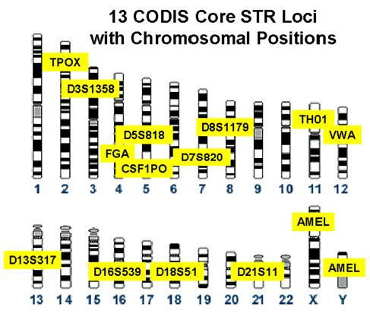

The human chromosomes and chromosomal locations (CODIS sites) at which the FBI looks for repeating DNA sequences.
For the class activity, note the TPOX region on chromosome 2. (X and Y count as one chromosome pair. The AMELs are not CODIS sites.)

Source: Biochemical Science Division, Chemical Science & Technology Laboratory, National Institute of Standards and Technology, http://www.cstl.nist.gov/div831/strbase/images/codis.jpg and http://www.cstl.nist.gov/div831/strbase/fbicore.htm

Base Pair Sequences
Chromosome  from father |  | Chromosome  from mother
G | C | G | C
A | T | A | T
A | T | A | T
T | A | T | A
G | C | G | C
A | T | A | T
A | T | A | T
T | A | T | A
 |  | G | C
 |  | A | T
 |  | A | T
 |  | T | A

TPOX region of chromosome 2 of hair found in bank robber’s glove.

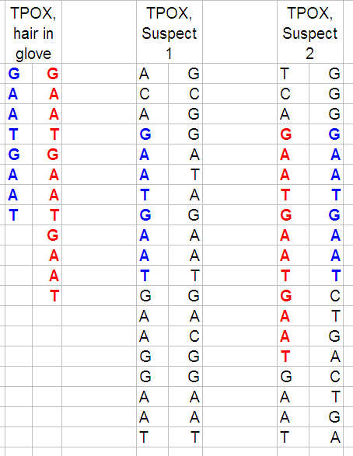

Comparison of the TPOX region of chromosome 2 of the unknown bank robber and two suspects.

