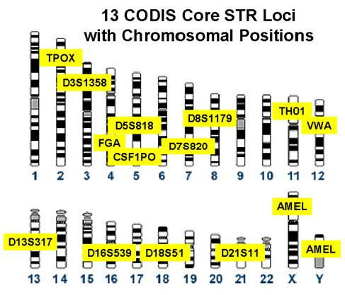

Suspect CODIS
Analysis Worksheet

CODIS site: D21S11
Hair in glove evidence |  | Suspect 1 |  | Suspect 2 |  | Suspect 3
G | G | A | G | A | G | T | G
T | T | C | C | C | C | C | G
A | A | A | G | G | G | A | G
G |  | C | G | T | T | G | G
T |  | G | G | A | A | T | A
A |  | T | T | G | T | A | A
G |  | A | A | T | A | G | T
T |  | G | G | A | G | T | G
A |  | A | T | G | T | A | A
 |  | A | A | T | C | A | A
 |  | T | G | A | G | T | T
 |  | G | T | G | T | G | C
 |  | A | A | A | A | A | T
- Which suspect’s DNA matches the DNA of the evidence hair at CODIS site D21S11? _____

CODIS site: TH01
Hair in glove evidence |  | Suspect 1 |  | Suspect 2 |  | Suspect 3
T | T | T | G | A | G | T | T
T | T | T | C | C | C | T | T
T | T | C | T | G | G | T | T
C | C | G | C | T | T | C | C
 | T | G | G | A | A | T | A
 | T | T | T | T | T | A | T
 | T | T | C | T | T | G | T
 | C | T | C | T | T | T | T
 |  | T | T | C | C | A | C
 |  | C | A | T | T | A | A
 |  | G | G | A | T | T | T
 |  | G | T | G | T | G | C
 |  | A | A | A | C | A | T
- Which suspect’s DNA matches the DNA of the evidence hair at CODIS site TH01? _____
CODIS site: VWA
Hair in glove evidence |  | Suspect 1 |  | Suspect 2 |  | Suspect 3
C | C | A | G | C | C | C | C
G | G | C | C | G | G | G | G
C | C | A | G | C | C | C | C
G | G | C | G | G | G | G | G
C | C | G | G | C | C | T | A
G | G | T | T | G | G | A | A
C | C | C | C | C | C | G | T
G | G | G | G | G | G | T | G
C | C | C | C | C | C | A | A
G | G | G | G | G | G | A | A
 |  | T | G | A | G | T | T
 |  | G | T | G | T | G | C
 |  | A | A | A | A | A | T
- Which suspect’s DNA matches the DNA of the evidence hair at CODIS site VWA? _____

CODIS site: AMEL
Hair in glove evidence |  | Suspect 1 |  | Suspect 2 |  | Suspect 3
A | A | A | A | A | G | T | T
T | T | T | T | C | C | T | T
C | C | C | C | A | A | T | T
G | G | G | G | T | T | C | C
 | A | G | A | C | C | T | A
 | T | T | T | G | G | A | T
 | C | T | C | A | T | G | T
 | G | T | G | T | T | T | T
 |  | T | T | C | C | A | C
 |  | C | A | G | T | A | A
 |  | G | G | A | T | T | T
 |  | G | T | G | T | G | C
 |  | A | A | A | C | A | T
- Which suspect’s DNA matches the DNA of the evidence hair at CODIS site AMEL? _____

- Based on your 4-site CODIS analysis, which suspect do you think is the bank robber? _____

- What is the chance that the suspect you think did it actually did not do it? (Remember, there is a one in 10 chance that one CODIS site will match.) ______________________________

- How would you increase the certainty of your result?

