Bridge Types & Forces Worksheet

For each image below, identify the following:
- Bridge type: beam, arch, modern suspension or cable-stayed bridge
- Which members have compressive forces acting on them
- Which members have tensile forces acting on them

1. Bridge type: ______________________________
Compressive forces are located in members: ______________________________
Tensile forces are located in members: ______________________________
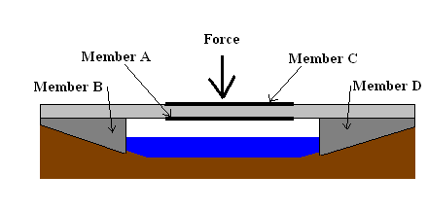

2. Bridge type: ______________________________
Compressive forces are located in members: ______________________________
Tensile forces are located in members: ______________________________
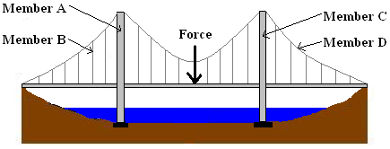

3. Type of Bridge: ______________________________
Compressive forces are located in members: ______________________________
Tensile forces are located in members: ______________________________
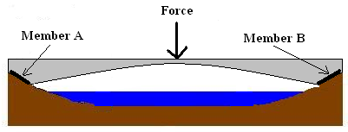

4. Type of Bridge: ______________________________
Compressive forces are located in members: ______________________________
Tensile forces are located in members: ______________________________
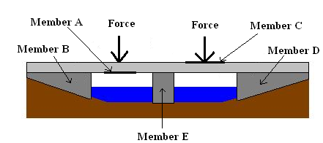

5. Type of Bridge: ______________________________
Compressive forces are located in members: ______________________________
Tensile forces are located in members: ______________________________
