Bridge Types & Forces Worksheet Answers

For each image below, identify the following:
- Bridge type: beam, arch, modern suspension or cable-stayed bridge
- Which members have compressive forces acting on them
- Which members have tensile forces acting on them

Beam bridge
B & D (piers), C (top of beam)
A (bottom of beam)
1. Bridge type: ______________________________
Compressive forces are located in members: ______________________________
Tensile forces are located in members: ______________________________
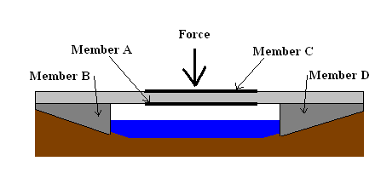

Modern suspension bridge
A & C (towers)
B & D (cables)
2. Bridge type: ______________________________
Compressive forces are located in members: ______________________________
Tensile forces are located in members: ______________________________
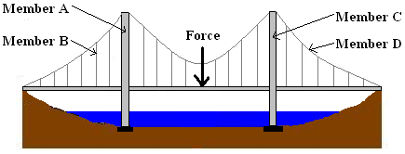

3. Type of Bridge: ______________________________
Arch bridge
A & B (abutments)
None
Compressive forces are located in members: ______________________________
Tensile forces are located in members: ______________________________
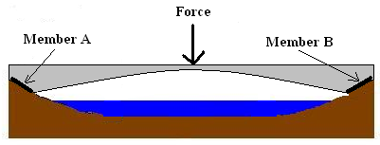

Beam bridge (2 spans)
B, D & E (piers), C (top of beam)
A (bottom of beam)
4. Type of Bridge: ______________________________
Compressive forces are located in members: ______________________________
Tensile forces are located in members: ______________________________
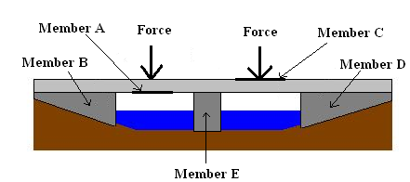

Cable-stayed bridge
A & C (towers)
B & D (cables)
5. Type of Bridge: ______________________________
Compressive forces are located in members: ______________________________
Tensile forces are located in members: ______________________________
