Foundations Math Worksheet
- Compare the actual bearing pressure that the shallow foundation produces and the allowable bearing pressure of the soil. Does the foundation fail? Why is σzD equal to 0? Show all your work and calculations.
Actual bearing pressure is q = force / area
The force, P, on the foundation is 100,000 lbs
The area of the bottom of the foundation is square with 10-foot sides
Allowable bearing pressure of the soil is q_{ult} = 6.28 x s_{u} + σ_{zD}
From soil investigations, s_{u} = 500 lbs/ft² and σ_{zD} is 0.
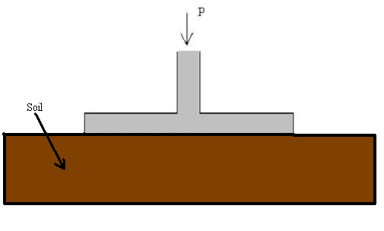

- Compare the actual bearing pressure that the shallow foundation produces and the allowable bearing pressure of the soil. Does the foundation fail? Show all your work and calculations.
Actual bearing pressure is q = force / area
The force, P, on the foundation is 200,000 lbs
The area of the bottom of the foundation is square with 7-foot sides
Allowable bearing pressure of the soil is q_{ult} = 6.28 x s_{u} + σ_{zD}
From soil investigations, s_{u} = 500 lbs/ft² and σ_{zD} is 110 lbs/ft²
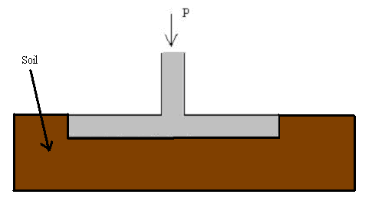

- Compare the actual load given for the deep foundation and the allowable ultimate load calculated. Does the foundation fail? Show all your work and calculations.
The actual load, P, on the foundation is 100,000 lbs
The allowable load P_{a} = q_{t}’ x A_{t} + f_{s} x A_{s}.
The area of the bottom of the foundation is circular with a 1-foot radius
Area of a circle = π * radius * radius
The area of the side of the foundation is the surface area of the foundation in contact with the soil. The area is the foundation circumference of the multiplied by the foundation length.
Circumference = 2 x π x radius π = 3.14
Length of the foundation = 40 feet
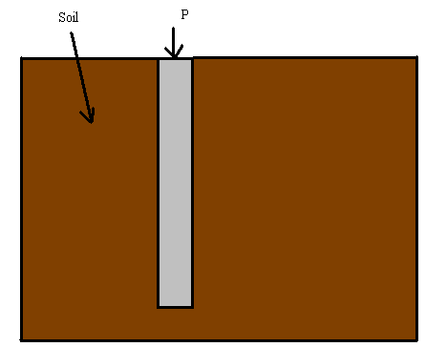From soil investigations, q_{t}’ = 3000 lbs/ft² and f_{s} = 600 lbs/ft²

