Foundations Worksheet
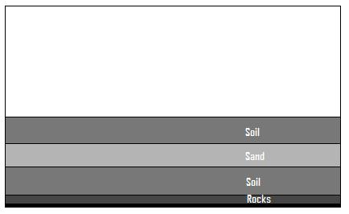
- Foundation 1: Holding on to the dowel end, place the block of wood directly on top of the soil. Then, pile books on it to create bearing pressure on the soil, as if this foundation was holding the load from part of a heavy bridge. Draw a picture of your first shallow foundation model in the space below.

What happens as you pile books on the foundation? Why? Record your observations here:

What is the final weight of the books you could balance on the foundation? ____________

- Foundation 2: Now, using the same block of wood, place it deeper in the soil so that the top of the block is level with the top of the soil. Next, pile books on it to create bearing pressure on the soil, as if this foundation was holding the load from part of a heavy bridge. Draw a picture of your second shallow foundation model in the space below.

What happens as you pile books on the foundation? Why? Record your observations here:

What is the final weight of the books you could balance on the foundation? ____________

- Foundation 3: Holding on to the wooden block end, point the dowel towards the soil and push it down into the soil. Next, pile books on it to create bearing pressure on the soil, as if this foundation was holding the load from part of a heavy bridge. Draw a picture of your deep foundation model in the space below.

What happens as you pile books on the foundation? Why? Record your observations here:

What is the final weight of the books you could balance on the foundation? ____________

- Calculations: Next we are going to find the actual bearing pressure exerted on our foundation models.
For the shallow foundations, use the following equation
Bearing pressure = Force ÷ Area (A_{e})
Force = the final weight of books balanced on the foundation
Area = the area of the bottom of the block. L x W, or 4in² (25cm²)

Calculate your pressure bearings for foundations 1 and 2 here. Remember to show your calculations.

For the deep foundation, use the following equations:
End bearing pressure = Force ÷ Area (A_{e})
Force = the final weight of books balanced on the foundation
Area = the area of the bottom of the dowel, π x radius x radius, or 0.8in² (5cm²)
Skin Friction = Force ÷ Area (A_{s})
Force = the final weight of books balanced on the foundation
Area = the area of the bottom of the dowel, 2π x radius x height, or 37.7in² (243.2cm²)
Actual Bearing Pressure = End Bearing Pressure + Skin Friction
Calculate your actual pressure bearings for foundation 3 here. Remember to show your calculations.

