Foundations Worksheet Answers
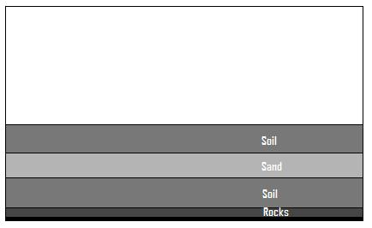
- Foundation 1: Holding on to the dowel end, place the block of wood directly on top of the soil. Then, pile books on it to create bearing pressure on the soil, as if this foundation was holding the load from part of a heavy bridge. Draw a picture of your first shallow foundation model in the space below.

What happens as you pile books on the foundation? Why? Record your observations here:
The soil pushes out to the sides and slightly up around the block of wood. This shows failing of the soil.

varies
What is the final weight of the books you could balance on the foundation? ____________

- Foundation 2: Now, using the same block of wood, place it deeper in the soil so that the top of the block is level with the top of the soil. Next, pile books on it to create bearing pressure on the soil, as if this foundation was holding the load from part of a heavy bridge. Draw a picture of your second shallow foundation model in the space below.

What happens as you pile books on the foundation? Why? Record your observations here:
Again, the soil pushes out to the sides and slightly up around the block of wood. The soil again fails due to high bearing pressure. However, the amount of force that must be applied to the wooden block is higher.

varies
What is the final weight of the books you could balance on the foundation? ____________

- Foundation 3: Holding on to the wooden block end, point the dowel towards the soil and push it down into the soil. Next, pile books on it to create bearing pressure on the soil, as if this foundation was holding the load from part of a heavy bridge. Draw a picture of your deep foundation model in the space below.

What happens as you pile books on the foundation? Why? Record your observations here:

The wooden dowel penetrates into the soil and becomes harder to push down into the soil as it gets deeper. If the wooden dowel is pushed hard enough, it reaches the rock layer at the bottom of the box. For a bridge or other large structure, piles would be placed to this depth to reach the more compact soils, clay and rock.

varies
What is the final weight of the books you could balance on the foundation? ____________

- Calculations: Next we are going to find the actual bearing pressure exerted on our foundation models.
For the shallow foundations, use the following equation
Bearing pressure = Force ÷ Area (A_{e})
Force = the final weight of books balanced on the foundation
Area = the area of the bottom of the block. L x W, or 4in² (25cm²)

Calculate your pressure bearings for foundations 1 and 2 here. Remember to show your calculations.

Varies according to the materials used

For the deep foundation, use the following equations:
End bearing pressure = Force ÷ Area (A_{e})
Force = the final weight of books balanced on the foundation
Area = the area of the bottom of the dowel, π x radius x radius, or 0.8in² (5cm²)
Skin Friction = Force ÷ Area (A_{s})
Force = the final weight of books balanced on the foundation
Area = the area of the bottom of the dowel, 2π x radius x height, or 37.7in² (243.2cm²)
Actual Bearing Pressure = End Bearing Pressure + Skin Friction
Calculate your actual pressure bearings for foundation 3 here. Remember to show your calculations.
Varies according to the materials used

