# Engineering Drawing Components

# Include these components in your detailed engineering drawings.

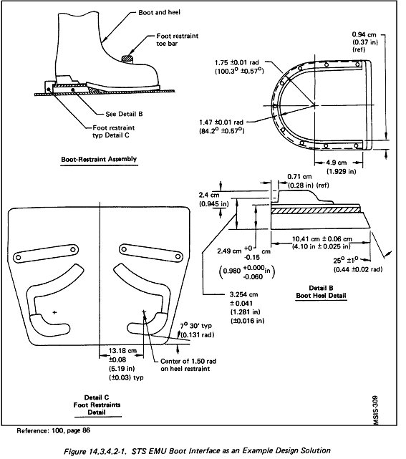

**Design details**

**Overall product drawing showing parts**

**Line drawings from different views**

**Specify materials & requirements**

**Dimensions and units**

**JSC 05/07/2008**

**Title**

**Initialed and dated**

*Drawing source:* NASA, <http://msis.jsc.nasa.gov/images/Section14/Image368.gif>

See more engineering drawings at: <http://msis.jsc.nasa.gov/sections/section14.htm#_14.1_GENERAL_EVA>

Drawing source: NASA, <http://msis.jsc.nasa.gov/images/Section14/Image368.gif>

See more engineering drawings at: <http://msis.jsc.nasa.gov/sections/section14.htm#_14.1_GENERAL_EVA>