Agricultural Engineering: Cutting through Soil Activity —
Name the Parts of a Plow Worksheet

Label the parts of the plow in the picture below:
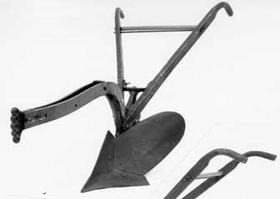

Source: http://www.fhwa.dot.gov/environment/Fspubs/96232802/fig14.jpg

What part is this plow missing?
Draw your new and improved plow in the space below.

