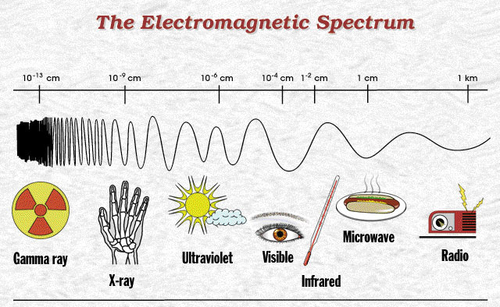

Source: Electromagnetic Spectrum, Cassini-Huygens Mission to Saturn & Titan, Mission – Navigation – Uplink/Downlink, Jet Propulsion Laboratory, California Institute of Technology, NASA, http://saturn.jpl.nasa.gov/mission/nav-uplink.cfm.
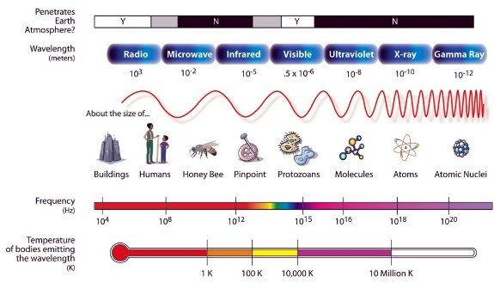
Source: The Electromagnetic Spectrum, Exploration of the Universe Division, Beyond Eistein from the Big Bang to Black Holes, SEU Technology, NASA, http://universe.nasa.gov/lifecycles/technology.html.

