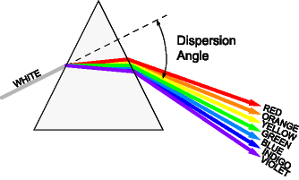
Source: RXTE Learning Center, Exploration of the Universe Division, Smithsonian Astrophysical Observatory, Goddard Space Flight Center, NASA, http://heasarc.gsfc.nasa.gov/docs/xte/learning_center/universe/prism.html.

Dispersion
Angle

