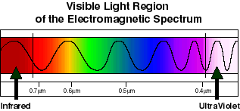
Visible Light Region
of the Electromagnetic Spectrum

Source: The Electromagnetic Spectrum, IMAGERS (Interactive Multimedia Adventures for Grade School Education Using Remote Sensing), GSFC Laboratory for Terrestrial Physics, NASA, http://climchange.cr.usgs.gov/info/sw/clim-met/anatomy/solar.html.
The colors and wavelengths of visible light in the electromagnetic spectrum.
Note the order of the colors (ROYGBIV), and their corresponding wavelengths. Red is the longest wavelength, violet the shortest.
The ultraviolet (UV) waves are even shorter than violet waves and cannot be seen by the human eye. UV light burns our eyes.
Infrared waves are even longer than red waves and cannot be seen by the human eye. This is close to the size of microwaves.
Infrared
UltraViolet

