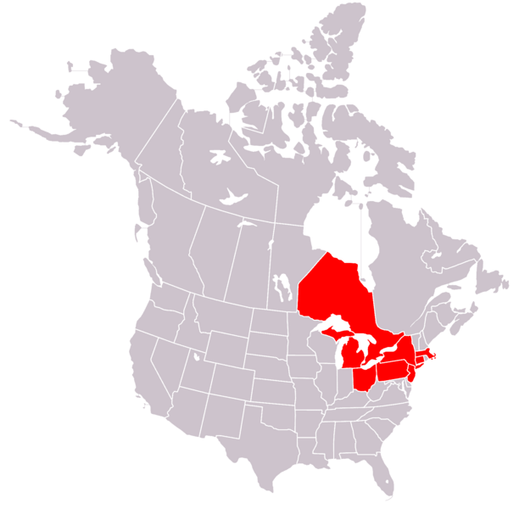
BLACKOUT! The Northeast Blackout of 2003
In August 2003, a massive power outage occurred in northeastern US and eastern Canada. This loss of electricity was the largest blackout in North American history! Approximately 10 million people in Canada and 45 million people in the US were without electricity, some for as long as three days.
What was it like?
Even though power was down, some important services continued to work, thanks to back-up systems that are able to generate electricity during blackouts. For example, phone systems still operated in most areas, but increased demand by people phoning home left many circuits overloaded. People were able to use their cell phones — until their batteries died! Even people who used cell phones experienced big service disruptions because the towers that transmit cell phone signals were overloaded with the huge increase in call volume. Television and radio stations mostly remained on the air with the help of back-up generators, which remained online throughout the blackout.
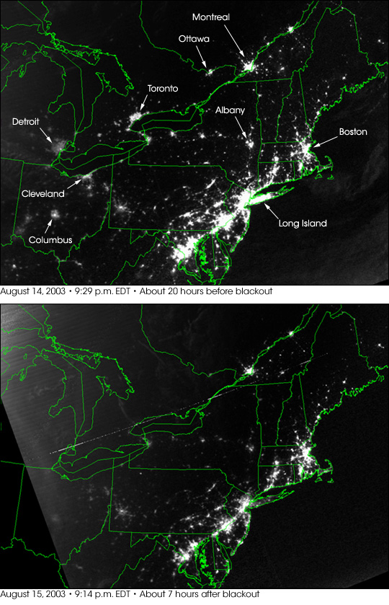
Because many water systems lost pressure, a“boil water advisory” was issued, meaning that people were advised to boil their water before using it. When water pipes lose pressure, pollution outside the pipes can sneak into the water supply. Boiling water is one method to make contaminated water safe again.
When the outage knocked out air conditioning, buildings became hot and people became angry, worried, overheated and at their wits end. Remember, the blackout happened during the heat of August! However, the huge surge in crime that had been feared by many, including law enforcement, never happened. When power was off after nightfall, the Milky Way and orbiting artificial satellites became visible to the naked eye in the sky above metropolitan areas where they can not ordinarily be seen because of light pollution.
⬆About 20 hours before blackout
(August 14, 2003, 9:29PM)
Restaurants were closed due to the boil water advisory and the loss of power. Shops and businesses also closed. Railroad lines were shut down. Airports were unable to function because they could not access electronic-ticket information, nor were they able to screen passengers. Many gas stations were unable to pump fuel due to the lack of electricity. Some people chose to wait in long lines for gasoline where it was available, while others simply drove until they ran out of gas! Many oil refineries were forced to shut down as the result of the blackout, and were slow to resume gasoline production. The limited gasoline that was available became very desirable, and thus expensive, as gasoline prices rose.
⬆ About 7 hours after blackout
(August 15, 2003, 9:14PM)
Life in New York City
In New York City, the subway shut down, and hundreds of people were trapped in elevators. When the power went out, more than 600 subway and commuter rail cars were trapped between stations. All of these people had to be rescued by the NYC fire department.
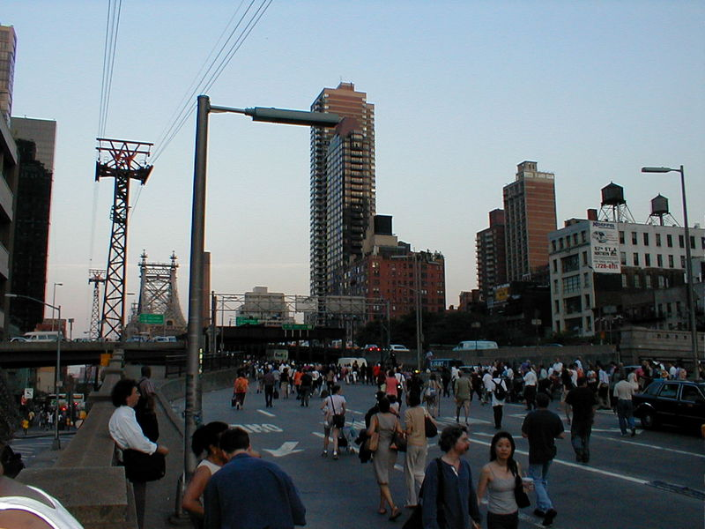
No traffic lights were working, so many roads were a chaotic mess. People in Manhattan fled their offices on foot; for hours into the evening the streets, highways, bridges and tunnels were jammed with traffic and pedestrians trying to leave Manhattan. The bus journey from Manhattan to Washington (which usually takes four hours) took more than eight hours! Mayor Bloomberg advised residents to open their windows, drink plenty of liquids to avoid heat stroke, and not to forget their pets. Because many people could not use cell phones, huge lines of citizens formed at pay phones.
While some commuters were able to find alternate sleeping arrangements, many were left stranded in New York and slept in parks and on the steps of public buildings. Practically all businesses, stores, and restaurants closed.
In New York, about 3,000 fire calls were reported, many from people using candles. The blackout contributed to at least eight deaths.
What Caused the Blackout?
The blackout occurred in August, so the weather was hot — almost 90ºF across much of the affected regions! In fact, some said that the heat played a role in what caused the blackout in the first place. The hot temperatures caused power lines to sag and energy demand to increase as people across the region turned to fans and air conditioning to beat the heat. Some speculate that lightning striking a power plant in New York was the cause. At first, terrorism was feared as a cause, but that idea was later ruled out.
A joint federal task force was formed by the governments of Canada and the US to investigate the cause of the August 2003 blackout. This task force was asked to search for the cause, and examine why the upgrades designed to prevent a repetition of the northeast blackout of 1965 failed. In February 2004, the task force issued a report that placed the main cause of the blackout on failure to trim trees in Ohio. The report said that high-voltage power lines went out of service when they came into contact with “overgrown trees.” The failure of these power lines led others to fail, and ultimately resulted in the shutdown of more than 100 power plants.
But — even so, no one is entirely sure what caused the blackout. This notorious blackout called into question the reliability and vulnerability of all electrical power grids.
Background Information on Electricity
Electrical power cannot easily be stored over extended periods of time, and is generally consumed less than a second after being produced! The demand on any power grid must be matched by the supply it is able to offer, and its ability to transmit that power. Any great overload of a power line can cause hard-to-repair and costly damage, so the power grid is disconnected if a serious imbalance is detected.
Power lines usually grow longer and sag between their towers when they heat up as they carry more power. If power lines touch the trees, they are supposed to automatically disconnect. These power changes from a line going out of service can sometimes cause other surrounding power lines to fail.
If power is lost in one area, power system operators take power from generators or other regions. In emergency situations, however, operators instead cut power to some areas.
Put Yourself in Their Shoes…
How would it feel if you were a commuter stranded in the city just as the rush hour was beginning? What would you do? What if you were stranded in a subway? Or, trapped in an elevator? Or, on a roller coaster? What if you lived in the city and had to make your way home through the streets and into your building in the dark and with elevators out of service? What if you were a shopkeeper concerned about looting? Or, a restaurant owner who had no power to keep food refrigerated or run cash registers, and suddenly had lots of hungry stranded customers? How would you keep medical equipment working for hospitalized people? What if you were a police officer or a fire fighter? How would you keep people calm and prevent crime as night fell? What if you were the mayor of the city? What information would you need to give the citizens to help keep them calm and safe?
Today, imagine yourself in the northeast blackout of 2003 and report on your experience as if it is happening right now!
- First, choose a perspective.
Write your story from the perspective of a person who experienced the blackout first hand.
Possible ideas:
- Stockbroker, who works in the city and lives in the suburbs
- Shopkeeper
- Restaurant owner
- Father or mother, whose child is at an after-school activity when the blackout occurs
- Nurse, caring for patients in a hospital
- Police officer
- Firefighter
- News broadcaster, who lives in the city
- Mayor of New York City
- Commuter, stranded in the subway
- Young woman or man, on the roller coaster at Coney Island with boy/girlfriend
- Pregnant woman, on an elevator
- Brainstorm, brainstorm, brainstorm…
On a piece of paper, write down your thoughts in the form of a web or outline. Really get into character and think about what your person might be thinking and feeling during the blackout.
How would his/her day be affected? Review the information above to get ideas and facts.
- Start writing! (Use the back of this sheet ➔)
Text source: Northeast Blackout of 2003. Updated September 7, 2010. In Wikipedia, The Free Encyclopedia. 2010. http://en.wikipedia.org/wiki/Northeast_Blackout_of_2003
North America 2003 blackout map source: Lokal_Profil, http://en.wikipedia.org/wiki/File:Map_of_North_America,_blackout_2003.svg
Before/After night satellite images source: Blackout Leaves American Cities in the Dark. Posted August 17, 2003. Earth Observatory, NASA. http://earthobservatory.nasa.gov/IOTD/view.php?id=3719 (high resolution images available at same website)
NYC street during 2003 blackout source: photographer Erik Skiff, User:Glitch010101, http://en.wikipedia.org/wiki/File:2003_New_York_City_blackout.jpg

