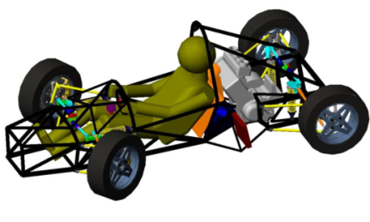
Engineering Drawing Survey
Circle yes or no.

- Describe how the car worked during testing.
- List some things about the drawing that you think were REALLY good.
- List some things you would tell the design group to help them make their drawing better. Remember to keep your advice positive.

