Example Engineering Drawings
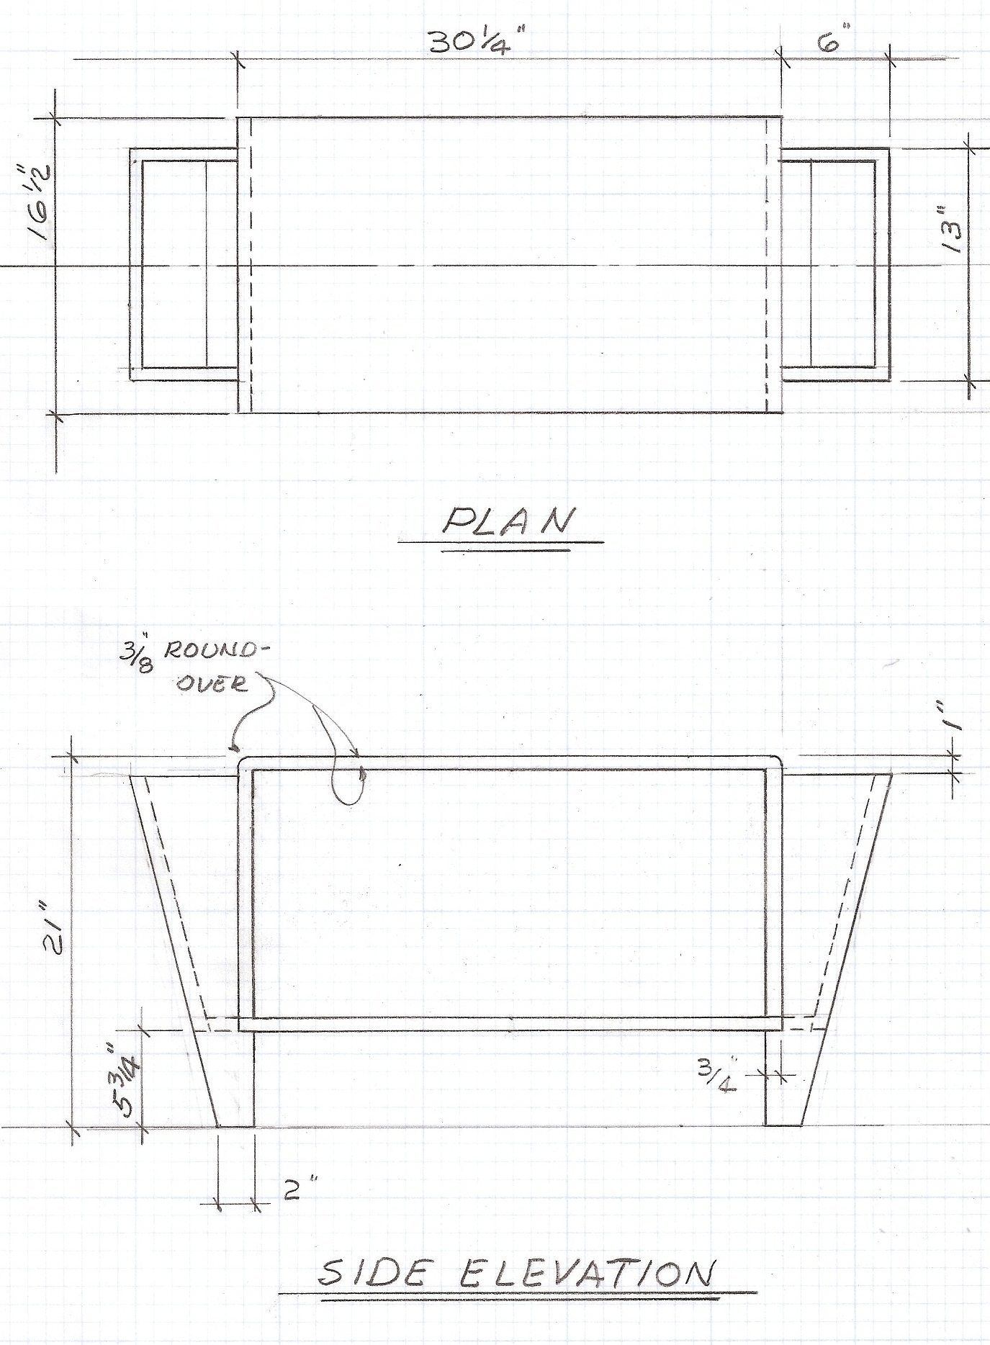
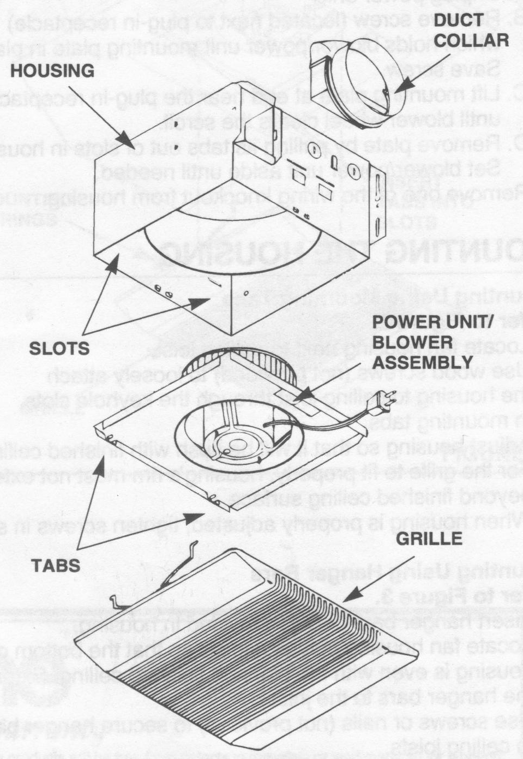
⬆ Exploded view drawing of bathroom exhaust fan

⬆ Student CAD drawings
Top view
⬆ Hand-drawn engineering drawing of a bench ⬇

Side elevation

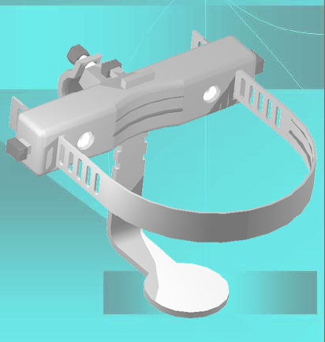
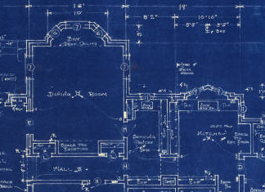
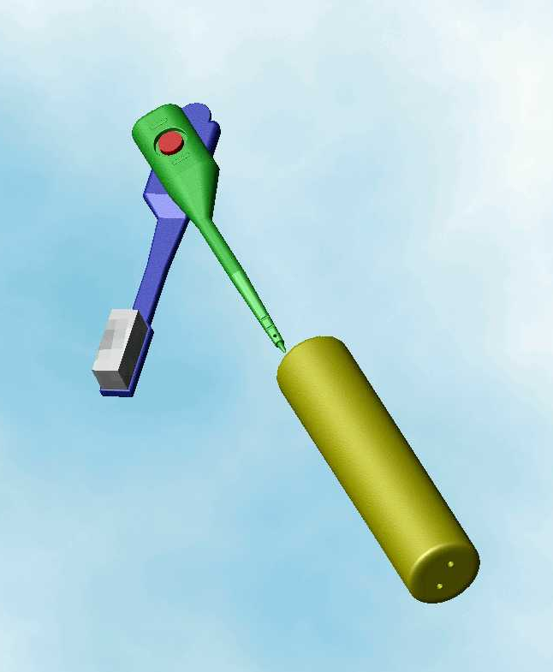
Modern
⬅ CAD drawings

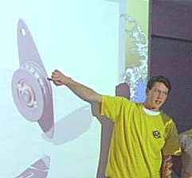
Traditional blueprint
of building design ➔

