ANSWER KEY
Groundwater Pollution Worksheet

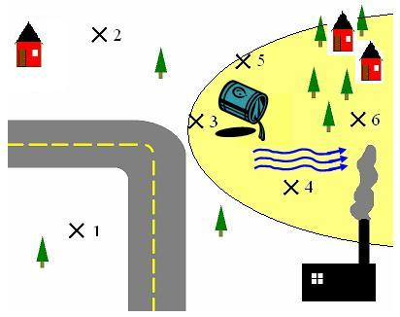

PART 1
- Find the pH at each sample site. Label the concentration as high (H), low (L) or none(N). Draw the direction of the contaminated groundwater flow on the diagram.

Sample # | pH | Concentration  (H, L or N)
1 |  | N
2 |  | N
3 |  | H
4 |  | L
5 |  | L
6 |  | L

- Why might the groundwater flow in that direction?
Answers will vary. The plume spreads in the direction of the groundwater. There is probably a hill or higher elevations on the left side of the map. Another reason might include the type of soil/substrate — such as high concentrations of clay on the left side of the map.
Now, we are going to predict how fast it will take for the contaminant to reach Community A using the diagram below. You will need a ruler.

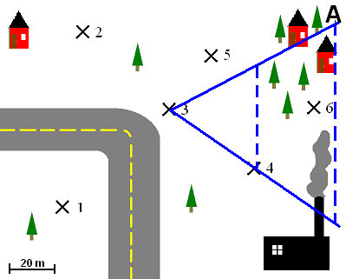

- First, soil samples were taken at site #4 over one year. On the 10th month, a rise in the level of contaminants was found. Find the velocity of the contaminant at sample site #4. Remember, Velocity (v) = distance (D) ÷ time (t).
D (measured with ruler) = 1.25 inch or 50 m [1.25” x (20 m /0.5”) = 50 m]
t = 10 months
v = D ÷ t
v = 50 ÷ 10
v = 5.0 m/month
- Next, we need to find the area of a cross-section of the contaminant plume at site #4 (shown by the dotted line). Remember Area (A) = width (w) x depth (d). We know that the groundwater is 1 meter in depth.
w (measured with a ruler) = 1.25 inches or 50 m
d = 1 m
A = w x d
A = 50 x 1
A = 50 m²
- We use the cross section of the area we just found to calculate the Flow (Q) of the groundwater over the whole area. Flow (Q) = Area (A) x velocity (v).
A (from #4) = 50 m²
v (from #3) = 5.0 m/month
Q = A x v
Q = 50 x 5.0
Q = 250 m³ /month
- Next, we need to find the area of a cross-section of the plume at community A (shown by the dotted line). Remember Area (A) = width (w) x depth (d). We know that the groundwater is 1 meter in depth.
w (measured with a ruler) = 2.25 inches or 90 m [2.25” x (20 m /0.5”) = 90 m]
d = 1 m
A = w x d
A = 90 x 1
A = 90 m²
- Then, we use our flow (Q) from above (assuming the flow is constant) to find the velocity of the contaminant at community A. We rearrange our flow equation to read Velocity (v) = Flow (Q) ÷Area (A).
Q (from #5) = 250 m³ /month
A (from #6) = 90 m²
v = Q ÷ A
v = 250 ÷ 90
v = 2.78 m/month
- Lastly, we rearrange our velocity equation to solve for the amount of time for the contaminant to reach Community A. Our equation now reads time (t) = distance (D) ÷ velocity (v).
D (measured with ruler) = 2.5 inches or 100 m [2.5” x (20 m /0.5”) = 100 m]
v (from #7) = 2.78 m/month
t = D ÷ v
t = 100 ÷ 2.78
t = 36 months
- Write your prediction for the time it will take the contaminated groundwater to reach Community A.
I predict the contaminated groundwater will reach the community in 36 months or 3 years.

Circle the groundwater treatment method you would choose for this site. Answers will vary.
Treatment Name | Description | Time
Containment (Physical barriers) | Placing something in the ground to stop the groundwater flow. | 1 year
Biological treatment | Adding microorganisms like bacteria that eat the contaminant to make it less toxic. | 10+ years
Chemical treatment | Adding chemicals like that react with the contaminant to make it less toxic. | 6 months-3 years
Soil vapor extraction | Moving air and vapors through the groundwater in order to remove the contaminant. | 3-5 years
Pump and treat | Pumping the contaminated water out of the ground, treat the water and put it back into the ground. | 5-10 years

PART 2: Remediation (ANSWERS TO PART 2 WILL VARY)

- Using the available tools for water treatment, brainstorm combinations to get your water sample clean. Make a list of your ideas. Be specific.

- Pick one treatment combination from your above list to test. This is your treatment process. Which treatment process did your group choose and why?

- Test your treatment process and write your observations here.

- Was your treatment process effective? Why or why not?

- What improvements would you make to your treatment process?

- Test your modified treatment process from #5 and write your observations here.

- Was your second process more effective than your first process?

- What recommendations would you make for treatment of this contaminated water?

- What constraints did you consider when you designed your treatment process? (Cost, environmental effects, time, etc.)?

