Fancy Feet Steps
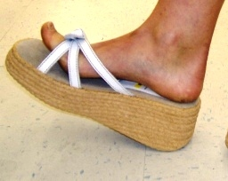
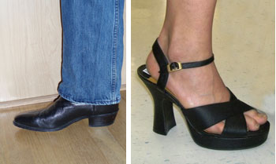
Today, there are thousands of different types of shoes and just as many engineers working to develop new styles and improve existing designs. High-heeled shoes raise the wearer’s heel higher than the toes. But high-heeled shoes are not just for women’s shoes; for example, cowboy and western boots are worn by men and women. Platform shoes raise both the heel and toe.
Use your imagination!

Step 1: Shaping the sole.
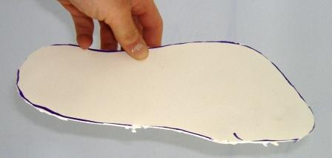
Create the soles of your foam core shoes by tracing your feet on the foam core board and cutting the shape using an Xacto™ knife.

Step 2: Fitting the shoe.
Mark the lines at which the sole should bend to fit your foot and create hinges in the foam core.
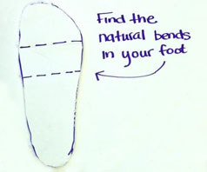
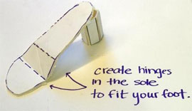

Step 3: Creating the lift.
With a little creativity, use your remaining foam core to create all sorts of cool designs for the shoe heel or platform! Examples: (left to right) cylindrical heel, crossed heel and triangular heel.
