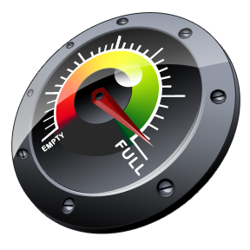
Heat Transfer: Hot Potato, Cold Foil Activity –
Do You Have the Capacity? Worksheet – Answers
Questions

Surely you have you ever gotten into a car on a cool day and noticed that the metal buckle on your seatbelt feels significantly cooler than other things in your car, such as the steering wheel or the center console.

Why do you think this is?
UThe metal of the seatbelt has a lower capacity to absorb heat for a given temperature change, and so more readily absorbs heat from your hand (encourage creative ideas, accept different thoughts and views).

How is it possible that two items made of different materials but at the same temperature can contain different amounts of energy?
UThey have different heat capacities (encourage creative ideas, accept different thoughts and views).

How do scientists and engineers know that the components in machines, such as an engine or a rocket, will not be overwhelmed and destroyed by the high amounts of energy to which they are regularly exposed?
UThey know, among other things, the components’ heat capacities.

