Cooling Load Analysis and Computation Worksheet
Part 1 — Psychrometrics
How to use a psychrometric chart: To use this chart, we must be given two independent values to locate our point of measure. If given, for example, wet bulb and dry bulb temperatures, we find the point on the chart at which those values line up and then read the dew point temperature and relative humidity.
Example: Find the dew point temperature and relative humidity inside a room with a measured wet bulb temperature of 60° F, and a measured dry bulb temperature of 75° F.
Dew point temperature: ≈ 52° F Relative humidity: ≈ 45%

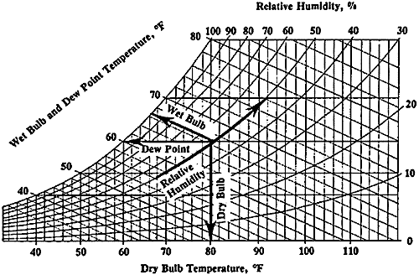

Part 2 — Design
We want a device that effectively cools supply air by using an evaporative cooling technique. Under the constraints of the materials below, design a device to accomplish this task.
2A.In the table below, list the function of each specific part of the device.
Material | Function
Electric Fan
Paper towels
Cardboard
Water (from spray bottle)

2B. Provide a basic sketch of your design:

2C. How could you make use of a circulating pump to improve the design and functionality of your device?

Part 3 — Build

Part 4 — Test and Analyze
4A. Record your observations in testing your swamp cooler design.

4B. Compare your observations to different groups in your class. Record notes about other designs.

4C. Identify reasons for differences in observations for your device compared to those of other groups.

4D. Use the 5,000-ft psychrometric chart to solve the following problems:
- Find the wet bulb and dry bulb temperatures inside a room with a relative humidity of 70% and a dew point temperature of 62° F. Is this room capable of effectively using an evaporative cooling system?

- Find the relative humidity and dew point temperatures in a room, given a wet bulb temperature of 54° F, and a dry bulb temperature of 79° F. Suppose you used a swamp cooler to cool the room down to 70° F, what kind of increase in humidity would be necessary to accomplish this?

- Find the dew point temperature inside a room with a relative humidity of 55% and a dry bulb temperature of 70° F. Suppose we are in the coldest month of winter causing the temperature of the inside of the windows to be around 45° F, would water vapor inside the room condense on the inside of the windows?

- What do you notice about the wet bulb and dry bulb temperatures inside any room with a relative humidity of 100%? What happens as the difference between the wet bulb and dry bulb temperatures increase?

- Suppose you need to choose a swamp cooling system for your home. Determine the rating of a swamp cooler (in CFMs, or cubic feet of air per minute) needed for the entire house (estimate square footage and ceiling height). Use the following formula:
CFM (ft³/min) = [Area (ft²) * ceiling height (ft)]/ 2 minutes

- Thinking about your observations and calculations, briefly explain how a swamp cooler works to lower the temperature of your home.

- Imagine that your home’s air conditioner consumes 5,000 kWh (kilowatt-hours) of electricity each year. The power plant that supplies electricity to your home is powered by coal. The power plant requires 1.07 pounds of coal to deliver 1.0 kWh. If your home used a swamp cooler instead of an air conditioner, how many pounds of coal would be saved every year? Assume the swamp cooler uses 70% less energy than the air conditioner. What is a drawback of the swamp cooler?

