Cooling Load Analysis and Computation Worksheet
Answers
Part 1 — Psychrometrics
How to use a psychrometric chart: To use this chart, we must be given two independent values to locate our point of measure. If given, for example, wet bulb and dry bulb temperatures, we find the point on the chart at which those values line up and then read the dew point temperature and relative humidity.
Example: Find the dew point temperature and relative humidity inside a room with a measured wet bulb temperature of 60° F, and a measured dry bulb temperature of 75° F.
Dew point temperature: ≈ 52° F Relative humidity: ≈ 45%

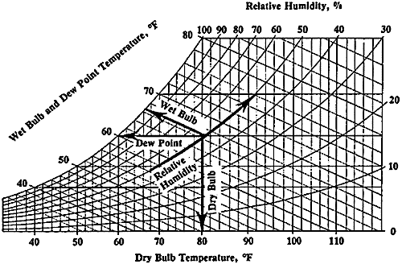

Part 2 — Design
We want a device that effectively cools supply air by using an evaporative cooling technique. Under the constraints of the materials below, design a device to accomplish this task.
2A.In the table below, list the function of each specific part of the device.
Material | Function
Electric Fan | Forces air to pass through the filter  and encourages evaporation.
Paper towels | Contain water to be evaporated.
Cardboard | Houses the fan and supports the paper towels.
Water (from spray bottle) | Keeps the paper towels saturated  to allow continual evaporative cooling.

2B. Provide a basic sketch of your design:

Sketches will vary.

2C. How could you make use of a circulating pump to improve the design and functionality of your device?

A pump could be used to pump water through the filter allowing it to be automatically saturated at all times, increasing the overall performance of the device.

Part 3 — Build

Part 4 — Test and Analyze
4A. Record your observations in testing your swamp cooler design.

Results will vary.

4B. Compare your observations to different groups in your class. Record notes about other designs.

Results will vary.

4C. Identify reasons for differences in observations for your device compared to those of other groups.

Results will vary.

4D. Use the 5,000-ft psychrometric chart to solve the following problems:
- Find the wet bulb and dry bulb temperatures inside a room with a relative humidity of 70% and a dew point temperature of 62° F. Is this room capable of effectively using an evaporative cooling system?
Answers:
Wet bulb: 65° F
Dry bulb: 72° F
No, the relative humidity is much too high.

- Find the relative humidity and dew point temperatures in a room, given a wet bulb temperature of 54° F, and a dry bulb temperature of 79° F. Suppose you used a swamp cooler to cool the room down to 70° F, what kind of increase in humidity would be necessary to accomplish this?
Answers:
Relative humidity: 20%
Dew point temperature: 34.5° F
Increase in relative humidity: 20%

- Find the dew point temperature inside a room with a relative humidity of 55% and a dry bulb temperature of 70° F. Suppose we are in the coldest month of winter causing the temperature of the inside of the windows to be around 45° F, would water vapor inside the room condense on the inside of the windows?
Answers:
Dew point temperature: 52.5° F
Yes, the temperature of the inside of the window is below the temperature at which water begins to condense.

- What do you notice about the wet bulb and dry bulb temperatures inside any room with a relative humidity of 100%? What happens as the difference between the wet bulb and dry bulb temperatures increase?
Answers:
They are the same
The relative humidity decreases

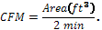
- Suppose you need to choose a swamp cooling system for your home. Determine the rating of a swamp cooler (in CFMs, or cubic feet of air per minute) needed for the entire house (estimate square footage and ceiling height). Use the following formula:
Answer: results may vary.
Example: 1800 sq. ft home, 8 ft ceilings.


- Thinking about your observations and calculations, briefly explain how a swamp cooler works to lower the temperature of your home.
When dry air passes over water, some of the water evaporates, and the relative humidity rises. Liquid water molecules become vapor in the dry air through a process that uses energy to change its physical state. Heat is transferred through convection from the higher temperature of the air, to the lower temperature of the water, resulting in cooled air.

- Imagine that your home’s air conditioner consumes 5,000 kWh (kilowatt-hours) of electricity each year. The power plant that supplies electricity to your home is powered by coal. The power plant requires 1.07 pounds of coal to deliver 1.0 kWh. If your home used a swamp cooler instead of an air conditioner, how many pounds of coal would be saved every year? Assume the swamp cooler uses 70% less energy than the air conditioner. What is a drawback of the swamp cooler?
Energy consumed by the swamp cooler = 5,000 kWh x 0.30 = 1,500 kWh
Coal used by the air conditioner = 5,000 kWh x 1.07 pounds/kWh = 5,350 pounds
Coal used by the swamp cooler = 1,500 kWh x 1.07 pounds/kWh = 1,605 pounds
Coal saved by the swamp cooler = 5,350 pounds – 1,605 pounds = 3,745 pounds
Possible drawbacks:
The swamp cooler uses water, which may be scarce in a dry climate.
The swamp cooler may not be effective if the humidity is too high.

