Breadboard and Circuit Diagram Basics
Circuit Diagrams
When engineers begin to design a circuit, they start by drawing a circuit diagram. A circuit diagram is like an instruction manual or map for the circuit. Other people can read the circuit diagram and build the exact same circuit. Engineers use specific symbols to show the locations of various circuit components. Table 1 shows some of the most common circuit components and their symbols.
Circuit Component | Symbol
Wire
Resistor | 
Capacitor | 
Inductor | 
Voltage source | 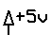
Switch | 
Ground | 
Node | 
Integrated circuit | various symbols
Table 1: Symbols for common circuit components.
Integrated circuits are also commonly found in circuit diagrams. The symbol used for an integrated circuit depends on its type. Every integrated circuit symbol displays the part number on the diagram and has numbers for each of the pins associated with the chip. Figure 1 shows two examples.
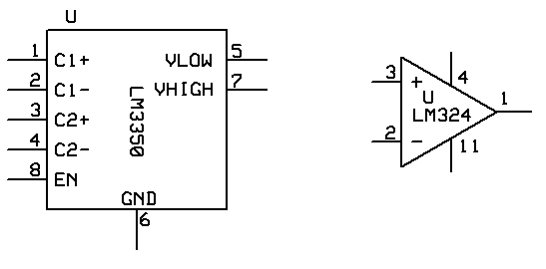
Figure 1. Examples of integrated circuit symbols used in circuit diagrams.
On the left, the part name of the chip is given in the center and the names for the pins are provided as well (C1+, C1-, etc.). The numbers next to the lines coming out of the symbol correspond to the pins. Each integrated circuit has a set way that its pins are numbered. Usually a mark on the actual chip (such as an indentation) helps the engineer orient the chip in the correct way. The pin numbering can be found in the schematics for the chip, often online. Figure 2 shows the RLC circuit — a basic circuit with some engineering applications.
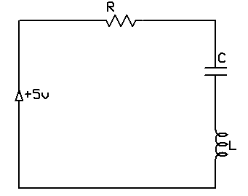
Figure 2. RLC circuit.
An RLC circuit contains a resistor (R), capacitor (C) and inductor (L) together in series with a voltage source. This diagram shows how the different components of the circuit should be connected together. Note that the voltage source first connects to the resistance R, and then R connects with C, and C with L and then back to the voltage source.
The circuit diagrams look a little bit different when dealing with integrated circuits. See Figure 3 for an example of a circuit diagram with an integrated circuit.
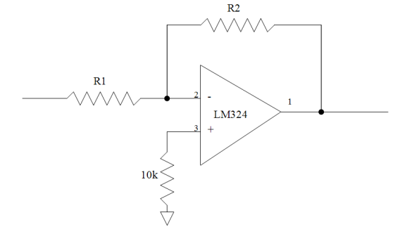
Figure 3. Circuit diagram with an integrated circuit.
Figure 3 shows a part of a larger circuit diagram containing an integrated circuit. The integrated circuit has numbers for three pins, each of which is connected to some other part of the circuit. (Note: Often an integrated circuit has more pins than are being used in a particular circuit. It is important to only connect components to the correct pin corresponding to the number in the circuit diagram.) In Figure 3, some input to the integrated circuit goes through a resistor (R1) and into pin 2 of the LM324 integrated circuit. A resistor is connected to both pin 3 of the integrated circuit and then ground. The output of this integrated circuit is located at pin 1. This output is connected to a feedback loop through another resistor (R2) and then back into the input at pin 2. The output also goes to some other part of the circuit.
Breadboards
The circuitry inside calculators and cell phones is all contained on what is known as printed circuit boards or PCBs (see Figure 4 for a PCB from a cell phone). PCBs are found in all electronic devices and contain the basic circuit components discussed above. However, PCBs do not allow for revisions if a component is placed in the wrong place while designing and testing a circuit. Since a circuit’s initial design is rarely its final design, it is first created using a tool that allows the engineer to easily move components around as needed. Engineers use breadboards (see Figure 5) when beginning to design, build and test a new circuit. A breadboard does not require soldering; it uses insulated wire.
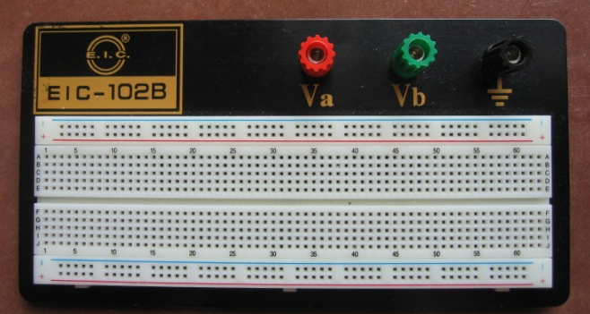
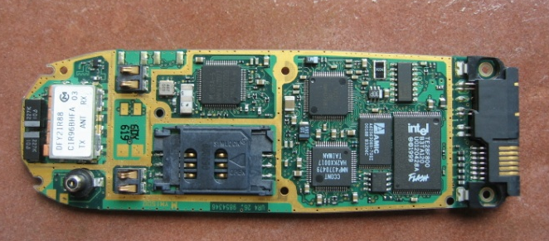

Figure 4. Example printed circuit board or PCB.
Figure 5. Example breadboard.
Breadboards come in a variety of sizes and shapes, but they all work the same way. They all have two distinct areas — bus strips and terminal strips. The bus strips are on the top and/or bottom of the breadboard; often, as in Figure 5, two bus strips are located across the top and two across the bottom of the breadboard. These strips are used to supply power and ground to the entire breadboard. The terminal strips make up the majority of the breadboard and are in the middle. The circuit is built on the terminal strips of breadboard, which are aligned into columns and rows with a split along the middle (if the breadboard is large enough). Each column (running from the top to the divide in the middle or from the divide to the bottom) has the same current going through it (components placed in the same column are going to be connected in series). Each row across the breadboard is not connected and does not have the same current running through it. To place components in the breadboard just requires placing the leads or pins of the component into the correct locations.
To supply power and ground to the terminal strips, a wire from the bus strip that is connected to power, and a wire from the bus strip connected to ground, must be connected to all the places in the terminal strips that require power or ground. For example, if a circuit diagram shows a resistor connected to one of the pins of an integrated circuit, you would take one lead (end) of the resistor and connect it to the power or ground. The other lead (end) must be placed into the same column that the pin of the integrated circuit is in. This runs voltage from the power source, through the resistor and then into the integrated circuit.
All circuit components are connected in a manner similar to the one just described. Often integrated circuits are placed with one row of pins on each side of the division in the middle because each side of the chip has pins this prevents them from becoming connected in series.

