Designing a Thermostat Worksheet

Most of us have a thermostat in our homes to control heating and cooling systems of our home. These important devices help us save energy by automatically turning off energy intensive equipment when not needed. How do these devices work? In this activity, we’ll use an electronic sensor and Ohm’s Law to design and build a thermostat.

Part 1: How can you measure temperature electronically?

- Obtain a breadboard, jumper wires, 9 V battery (with battery connectors), and an LM35 Temperature Sensor chip. Build the circuit shown to the right.  To save energy, connect the battery only when taking measurements. | 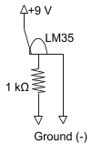 | 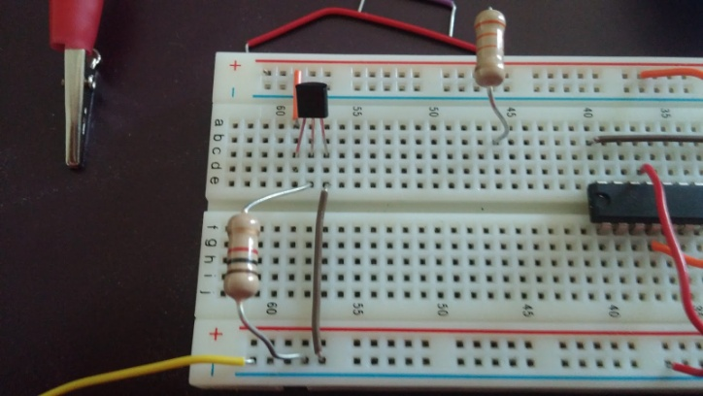
- With a multimeter, measure the voltage across the 1 kΩ resistor. You should get a positive value around 0.23 V. Rub your hands together and touch the top of the LM35 sensor. What happens to the voltage reading?

- Now let’s calibrate the sensor by developing an equation we can use to convert from voltage to temperature in Celsius (ºC). Hint: Rub your hands together to heat them up.

- Complete table to the right, measuring the room and your palm with a thermometer and the circuit you just built. |  | Voltage (V) | Temp (ºC)
 | Room
 | Palm

  - Assume a linear relationship between voltage across the 1 kΩ resistor and temperature. Using your data, develop an equation to determine voltage across the 1 kΩ resistor in terms of temperature (ºC).

Part 2: How can you “set” the thermostat?
- Let’s set the thermostat in cooling mode so it turns on when the temperature goes above a certain degree.
  - What temperature do you want to “set” your thermostat? Make sure this set point is lower than your palm temperature but higher than room temperature.

  - What is the LM35 voltage output that corresponds to this temperature?

- Now you need divide the 9 V supplied by the battery so that part of the circuit equals the LM35 output voltage for your desired temperature.  We’ll move the 1 kΩ resistor (R₂) over and combine it with another (R₁) as shown. | 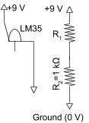 | 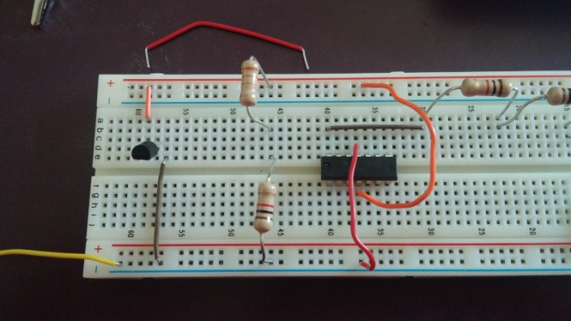
  - Which choice correctly compares the voltage drop across R₁ (V₁) and the voltage drop across R₂ (V₂)?
i. V₁+V₂ = 9 V  ii. V₁ = V₂ = 9 V | iii. V₁+V₂ > 9 V  iv. V₁+V₂ < 9 V
  - Which choice correctly compares the current through R₁ (I₁) and the current through R₂ (I₂)?

- I₁ < I₂ | ii. I₁ = I₂ | iii. I₁ > I₂
  - Which choice correctly indicates the relationship for the current through the voltage divider?
i. I=(R₁+R₂)/V_{Bat}  ii. I=V_{Bat}/R₁ | iii. I=V_{Bat}/(R₁+R₂)  iv. I=V_{Bat}(R₁+R₂)

d. Which choice correctly indicates the voltage drop across R₂ (V₂).
i. V₂=I/R₂  ii. V₂=IR₂ | iii. V₂=R₂/I  iv. V₂=I + R₂

- With the relationships between current and voltage from (5), you can determine an equation to quantify the value of R₁.
  - Substitute the equation for (5c) into the equation for (5d).

  - Solve the equation you just found for R₁.

  - Plug in the known values (V_{Bat}=9 V, R₂=1 kΩ, V₂ set point) into your equation and calculate the value needed for R₁.

- Obtain the necessary resistor (s) and build your divider as shown to the right. Use the multimeter to ensure you obtained the desired value for V₂. Is it correct?

Part 3: Does the light turn on when it is supposed to?
- Now you can connect your LM35 sensor and voltage divider to an operational amplifier (LM324). Add the LM324, 2 kΩ resistor, light emitting diode (LED) and connections shown to the right to your breadboard. NOTE: The bridges show where wires are NOT connected.
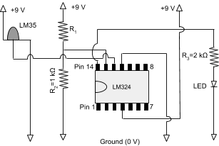 | 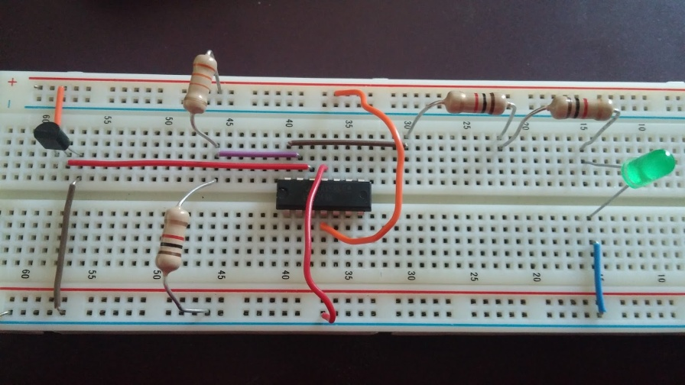

- Connect the 9 V battery to the circuit and measure the voltage across R₂. Is it still at your desired value? (Remember to disconnect the battery between measurements).

- The LM324 compares the voltage from Pin 13 (V₂ of the LM35) to ground and from Pin 12 (V_{out} of the LM35) to ground. If the voltage across Pin 13 is greater than Pin 12 then no voltage will be supplied to Pin 14. If Pin 13 is less than Pin 12, the LM324 supplies voltage to Pin 14, turning on the LED.

Warm up your hands by rubbing them together and touch the top of the LM35 sensor with your palm. Measure the voltage from the output of the LM35 sensor (Pin 12 to ground) as you heat the LM35 with your palm. Does the circuit behave as it should? Explain.

- What should happen when the LM35 reaches room temperature again?

Part 4: Can a thermostat save energy?
- Why would it be beneficial to increase the thermostat set point when nobody's home?

- What temperature should the thermostat be set at when nobody’s home? What LM35 voltage does this correspond to?

- Redesign your thermostat for the “nobody’s home” situation. Show calculations below and build it. Does it work?

Part 5: Can you use the circuit for a heating circuit?
- In a heating circuit, the heater turns on when the temperature gets too low. Adjust the circuit so it will work for heating. Note how you changed the circuit and show calculations below. Obtain a bag of ice or cool object and see if it works.

Need to do the following:
- Adjust R₁ so the set point is BELOW room temperature (maybe 19ºC).
- Switch connections to Pin 13 and Pin 12. Now the LM35 should be connected to PIN 13 and V₂ should be connected to PIN 12. Initially, room temperature (LM35) will be higher than the set point. Then the temperature of the LM35 goes below the set point it will turn on the circuit since the voltage to Pin 12 will be greater than Pin 13.

Part 6: Can “on” and “off” be at different temperatures?
- Why would you want “on” and “off” to be set at different temperatures?

- Continuing to use the heating circuit, complete the table below.
State | Temperature (ºC) | LM35 Voltage (V)
Turns On (lower limit)
Turns Off (upper limit)

- The addition of one resistor (R₄) will make different “on” and “off” points for this circuit.  To figure out the value of R₄ you first need to figure out the voltage supplied to Pin 14 for your circuit. Measure the voltage drop from Pin 14 to ground when the LED is on. | 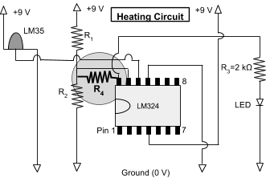

- Now you can use Ohm’s Law (V = RI) and your understanding of series circuits to develop an equation for R₄. Let’s begin by looking at the voltage drop through R₂ and R₄ when the LED is lit.

Which choice correctly compares the voltage drop V₂, V₄, and V₁₄.
- V₁₄ = V_{2,U} = V₄  - V₁₄ = V_{2, U} - V₄ | c. V₁₄ = V_{2,U} + V₄  d. V₁₄ = V₄ - V_{2, U}

- Now consider the current through R₄. Which choice correctly compares the current through R₄ to the current through R₂ at the upper and lower limit?
- I₄ = I_{2,U} + I_{2,L} | b. I₄ = I_{2,U} - I_{2,L} | c. I₄ = I_{2,U} = I_{2,L}

- Use Ohm’s Law (V = RI) to develop an equation for V₄ in terms of current I₄ and R₄.

- Use Ohm’s Law again to develop an equation for I_{2,L} (in terms of V_{2,U} and R₂) and I_{2,U} (in terms of V_{2,L} and R₂).
Equation for I_{2,L} in terms of V_{2,L} and R₂ | Equation for I_{2,U} in terms of V_{2,U} and R₂

- Challenge: Combine equations from (19) through (22) to develop an equation for R₄ in terms of V₁₄, V_{2,U}, V_{2,L}, and R₂.

- Now, put in the appropriate R₄ and test it. Did it behave appropriately? Explain.

