Solar Elevation vs. Azimuth Plot for Boulder, CO, USA
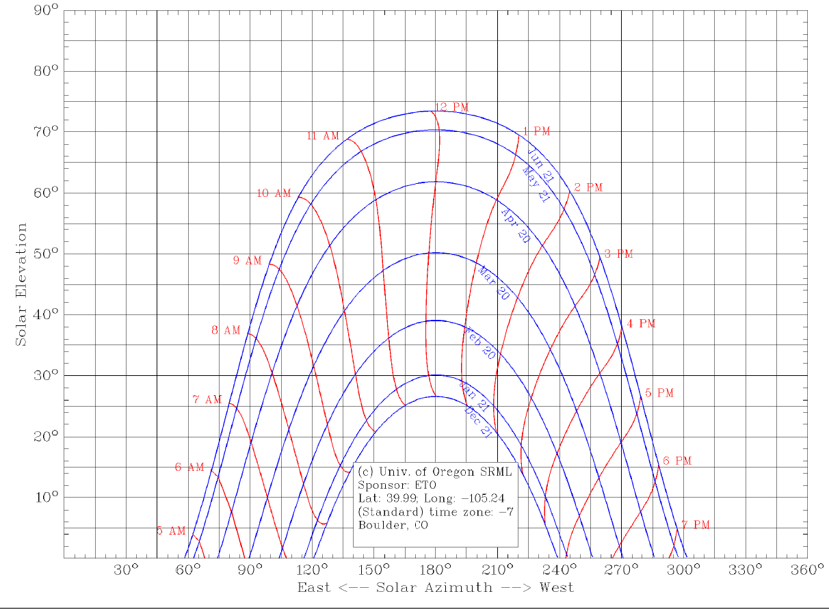

Plot source: University of Oregon Solar Radiation Monitoring Laboratory. http://solardat.uoregon.edu/cgi-bin/SunChart.cgi
Use this website to create your own plot for your location.

A plot of the solar elevation at certain azimuths throughout the day for Boulder, CO, USA. Data is included for six months; the other six months repeat the data.

