Solar Geometry
— A Look into the Path of the Sun
When designing any type of system that relies on solar radiation, it is important to take into consideration the seasonal and hourly changes in position of the sun. This has a direct influence on the incident angle of sunlight, so it is valuable to incorporate a system that can adjust to the position of the sun. It is also helpful to consider the position of the sun when deciding the placement of a structure’s windows.
The position of the sun can be described by two different angles. The first angle is the solar azimuth (denoted by α, alpha), which is defined as the clockwise angle between the sun and the cardinal direction of true north. It is measured up to the horizontal projection of the sun’s position onto the Earth’s surface (see Figure 1). The second angle is the solar altitude or elevation (denoted by Φ, phi), indicating the angle of the sun’s position from the horizontal (see Figure 1). The angle of incidence is not a measure of the sun’s position, but rather a measure of the amount of radiation incident on a vertical surface. The angle of incidence is related to the solar altitude as follows:

Together, the two angles provide useful information about the orientation of incoming sunlight on an object or structure. Knowing this, solar collectors and other devices should be installed so they are within 20° of either side of perpendicular to the sun. By incorporating a system that adjusts to the incident angle of the sun, we can further control the angle incident on the surface of the collector. For example, hinging light shelves so they are adjustable for the optimal angle.

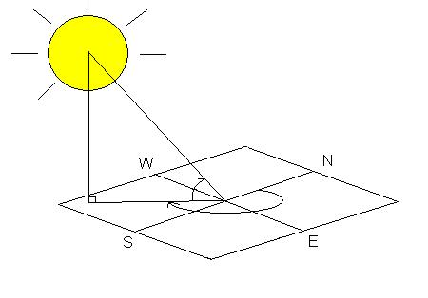
α: solar azimuth
α
Φ: solar altitude
Φ
θ: angle of incidence
θ
Earth’s surface

Figure 1: Solar geometry diagram.

Tilt of the Earth
The Earth is tilted about 23.5°on its pole-to-pole axis, relative to the horizontal plane of its orbit. This results in a 47° peak solar altitude angle difference, causing the hemisphere-specific difference between summer and winter. In the northern hemisphere, the sun remains on the south-facing (equator-facing) side of the house all day long, and varies in its incident angle.
In the northern hemisphere, due to the Earth’s tilt, the solar altitude approaches its minimum during the winter; the converse is true during the summer. This is critical to take into consideration when designing a structure’s windows and shading (see Figure 2). Because of the reduced solar altitude during the cold season, desirable radiation and natural light can enter deep into the interior space. While the strategic placement of roof overhangs above the windows prevents undesirable extra sunlight radiation from entering a space during the hot season.
summer sunlight

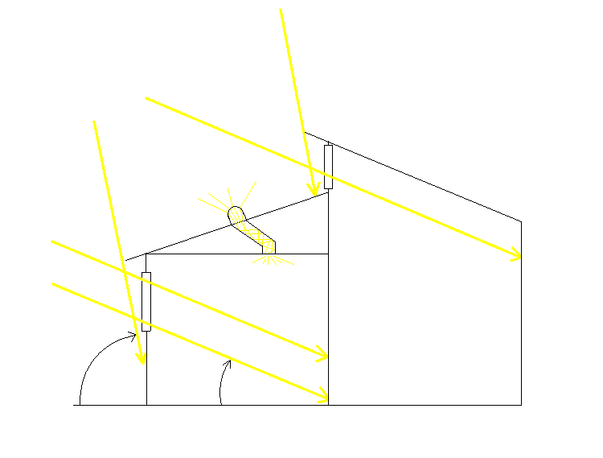
winter sunlight
Φ_{winter}
Φ_{summer}
clerestory window
solar tube

Figure 2: Example window and shading placement that takes into consideration
the range of winter and summer solstice sun angles.
The Figure 2 diagram shows a typical house with windows facing toward the equator (which is south if in the northern hemisphere). Notice the difference of the incident angle of sunlight during the winter and summer (Φ_{summer} > Φ_{winter}). Careful house design permits solar radiation to enter only during the winter season. Since sunlight does not directly enter the windows during the summer, it is beneficial to incorporate daylighting techniques to illuminate the interior.
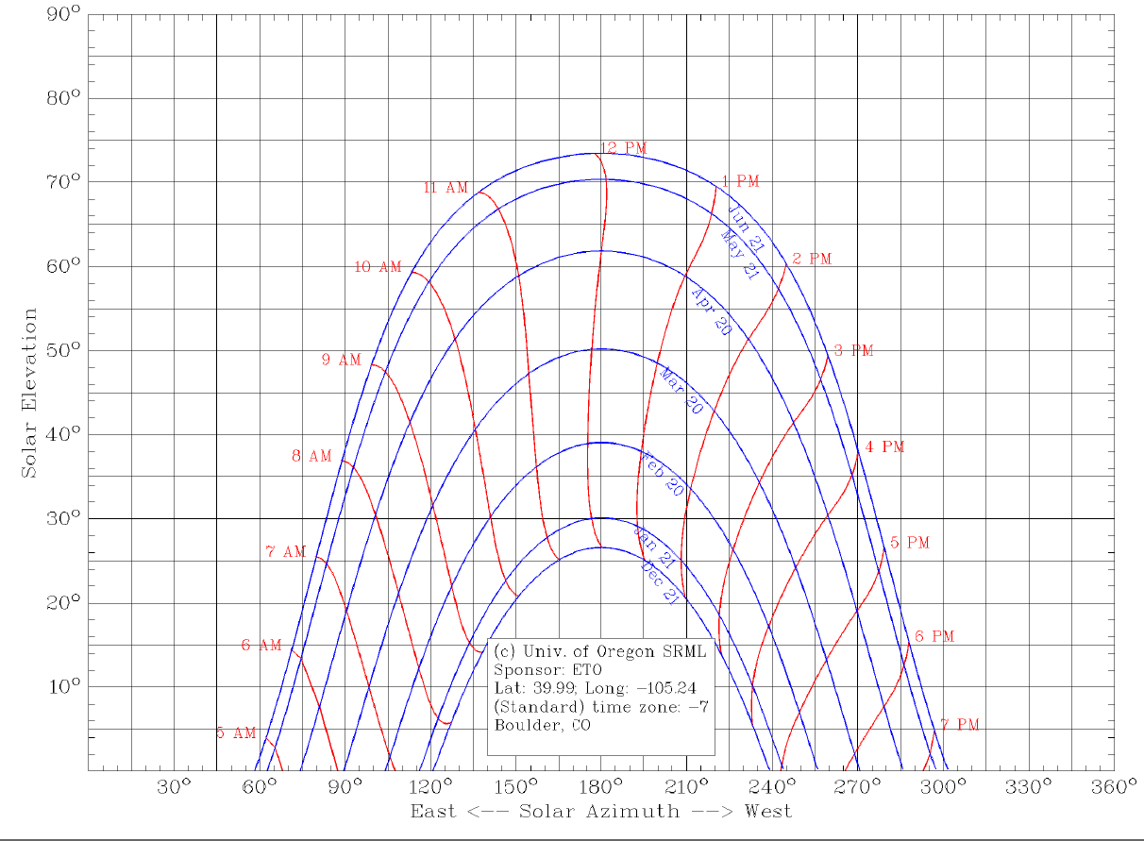
Solar tubes can emit enormous amounts of natural light while taking up very little roof space. These are preferable for summer conditions because they do not allow nearly as much heat transfer as would a typical window. Light shelves also bring in a considerable amount of daylight without much solar heat gain. When installing these devices on a structure it is important to place them where they may operate optimally. For example, place solar tubes on an area of the roof where sunlight is never obstructed by any other part of the structure during the course of a day.

Figure 3: Solar elevation vs. azimuth for Boulder, CO
Figure 3: Solar elevation vs. azimuth plot for Boulder, CO, USA.
Data is included for six months; the other six months repeat the data.
For a specific location, Figure 3 provides a plot of the solar elevation at certain azimuths throughout the day for all months between summer and winter. With this information, and given the time of day, a solar azimuth and elevation can be extrapolated to learn the sun’s position at any time, which is quite useful when designing anything that must incorporate the sun’s position into its functionality.
Plot source: University of Oregon Solar Radiation Monitoring Laboratory.
http://solardat.uoregon.edu/cgi-bin/SunChart.cgi
Use this website to create your own plot for your location.

