Greenhouse Design & Testing Worksheet

Answers
Part 1 – Design
In the space below, provide a simple sketch of your model greenhouse.
Sketch:

Answers will vary

Heat Transfer
List the different types of heat transfer that occur within and around the structure. Indicate them on your sketch.

- Solar radiation transmitted through the glass
- Conduction from the higher inside temperature (through the glass) to the lower outside temperature
- Natural convection at the interior and exterior surfaces (negligible)

Part 2 – Testing
Determine the ambient (initial) temperature of the outdoor air. Place your greenhouse under direct sunlight with the thermometer inside. At each specified time interval, take a temperature reading inside the greenhouse. Also keep a record of the ambient outdoor temperature at the same time intervals.
Results will vary. See example in table.
Elapsed Time (minutes) | Inside Greenhouse Temperature (°C) | Outside Greenhouse Temperature (°C)
0 minutes (ambient outdoor temperature) | 22.0 | 22.0
5 minutes | 22.5 | 22.0
10 minutes | 23.1 | 22.0
15 minutes | 23.6 | 22.0
20 minutes | 24.2 | 22.0

Part 3 – Graph the Results
On the axis below, plot the temperature readings inside and outside your model greenhouse as a function of time. Make the two lines different colors and include a legend to explain what the two colors represent. Make sure to include a title and appropriate labels.

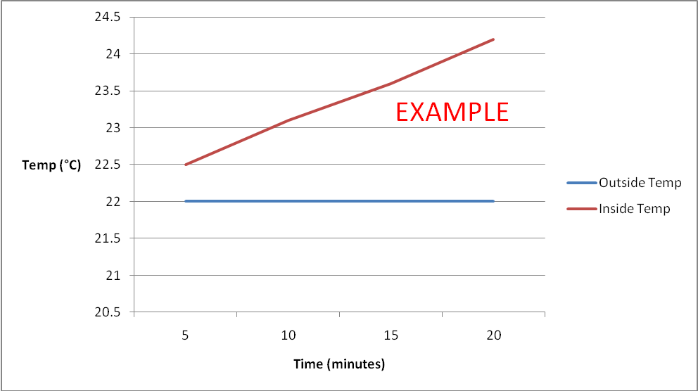

Part 4 – Analysis
- Looking at your graph, how does the temperature condition in your greenhouse compare to the ambient temperature of the air?
The inside greenhouse temperature grew warmer over time, compared to the unchanging ambient air temperature. It became warmer inside the greenhouse than outside the greenhouse.
- Explain the general shape of the lines on your graph and what they mean in terms of the performance of the greenhouse. What do the two different lines indicate?
The inside temperature line slopes upwards, indicating a continued rise in temperature over time. This means that the greenhouse air warmed up, and did not mix or leak to the outside. The straight, horizontal line of the outside temperature indicates that it remained constant (unchanged) for the duration of the testing.
- Suppose you want to use the greenhouse year round. On a cold and cloudy winter day, the greenhouse must be able to maintain a warm-enough temperature to keep plants from dying. Since no sun is shining, radiation heat gain is virtually nothing, so a heater must be installed to make up for heat losses in the greenhouse. Suppose your plants require a minimum indoor temperature of 19°C. Calculate the rate of heat that must be supplied to your greenhouse given an outdoor average temperature of -9°C, and the geometry of your model. Neglect convection heat transfer since it is relatively small compared to conduction. To represent a more realistic situation, assume your model is made out of glass.
Property | Value | Units
, thickness of the glass | 0.01
, thermal conductivity of glass | 1.05

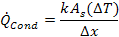

Note: A_{s} refers to the surface area of your model. You must calculate this according to your dimensions (also, this must be in meters!).
Example: A_{s} = 0.5 sq. meters
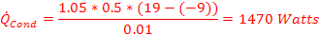
1470 Watts
Answer:
- What is one way of preventing some of the heat loss during these conditions?

Possible answer: Install some sort of temporary insulation.

