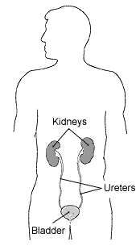

Source: http://kidney.niddk.nih.gov/kudiseases/pubs/yourkidneys/index.htm

