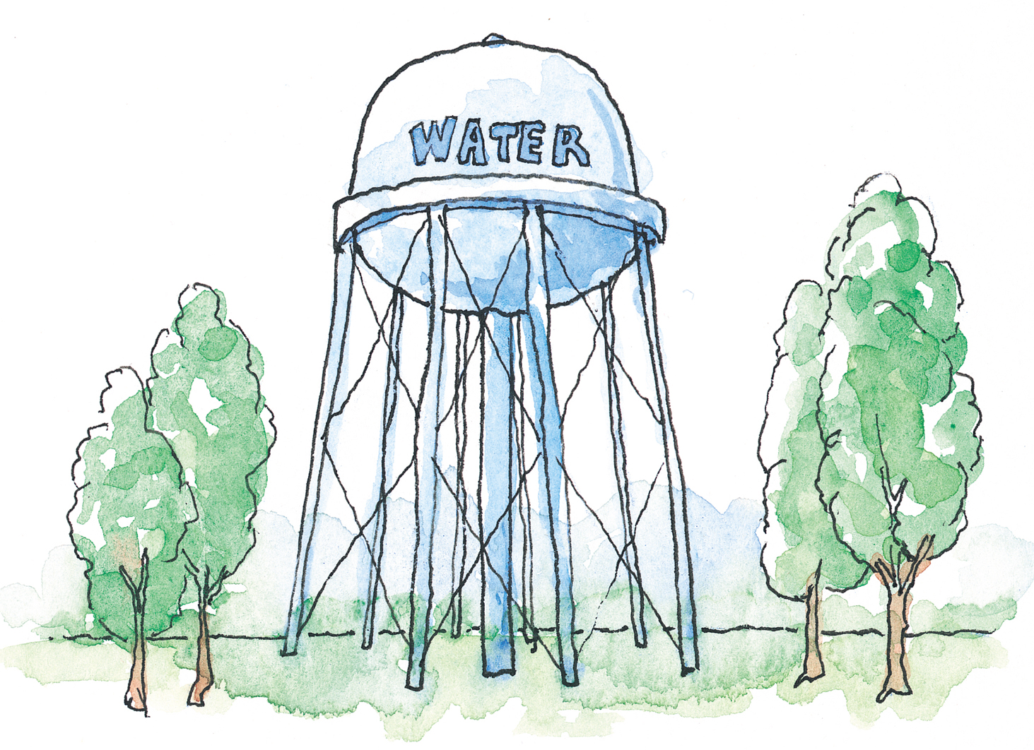
For Those at Home Activity –
Engineering Quiz - Answers

List seven different types of engineering:
Biomedical, Environmental, Civil, Chemical, Electrical, Mechanical, Aerospace
List three types of engineers and give examples of their responsibilities:
Biomedical: focus on engineering for the human body — helping athletes (via new body parts), people who are sick or have a disability, creating new medicines.
Environmental: focus on keeping air and water clean for humans and animals — cleaning water, preventing pollution, treating wastewater.
Civil: focus on infrastructure — building roads, bridges, highways, buildings.
Chemical: focus on creating materials — foods, candy, fuels, medicines.
Electrical: focus on designing and building electrical systems — computers, TVs, DVDs, anything with electricity and wiring.
Mechanical: focus on things that move — mechanical parts, gears, building both small and large designs from tiny robots to cars.
Aerospace: focus on engineering for space — rockets, space shuttles, airplanes.
What do you think is a good definition of engineering?
Engineering is using math and science to solve real-world problems, help the environment and help people, creating things for the benefit of society. (Whatever the students write is fine – this should be their own definition.)
Which type of engineer works on making the environment (air and water) clean for people and animals?
An environmental engineer.
Give an example of an engineering constraint:
A constraint is considered a limit – so anything that limits a design (cost, size, shape, color, location, height, etc.) could be considered a constraint.
Give an example of something that engineers designed that helps athletes to stay safe:
Padding, helmets, catcher’s mask, gloves, mouth guards, shin guards, etc.
Why do engineers need to know about different kinds of materials?
So that they can choose the best material (best quality vs. lowest cost vs. availability, etc.) to use for their design.
Which kind of engineering most fascinates you? Why?
This one is up to the students! This question leads in well to a class discussion of which engineering students like the best. Encourage students to picture themselves as future engineers!

