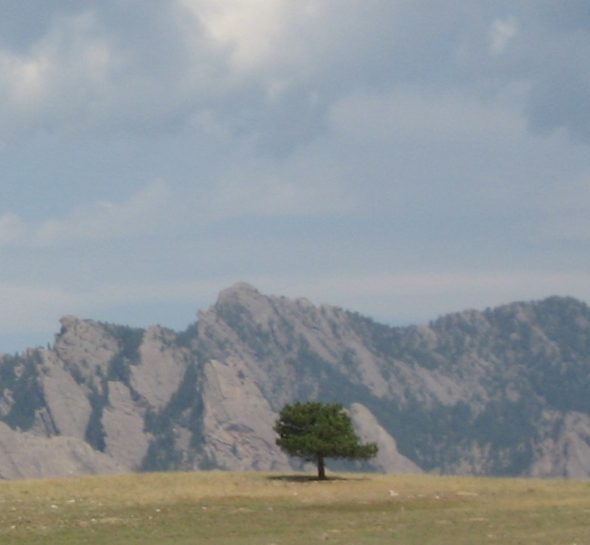
Re-Building the Forest Worksheet

The Truffula Tree:
1 year to sprout
10 years to become a sapling
10 more years to become an adult tree and make 10 seeds*
* each tree makes 10 seeds per year

Year | # of Seeds | # of Sprouts | # of Saplings | # of Mature Trees

