Student Instructions Handout

Part 1: Making the Motor
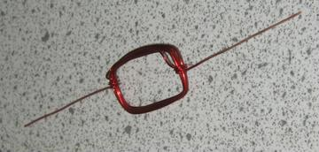
- Start about 1.5 in (38 mm) from the end of the wire and wrap it seven times around the short side of a rectangular magnet. Gently slide out the magnet, careful to not alter the rectangular shape of the wire. Leaving a 1.5 in (38 mm) tail opposite the original starting point, cut the wire with wire cutters or needle-nose pliers. Carefully wrap each of the two tails around the coil (closest to that end) so that the coil is securely bound together, and the two tails extend perpendicular to the coil. Your coil should look similar to Figure 1. Note: Be sure that the tails are opposite each other on the coil.

Figure 1. Magnet wire coil.

- On one tail, use sandpaper to remove the insulation completely from the end of the tail up to ¼ in (6 mm) from the point at which the tail meets the coil. This tail should look like the left tail in the wire cross section in Figure 2. On the other tail - again leaving a ¼ in (6 mm) section of wire at the point of connection with the coil - lay the coil flat and carefully sand off the insulation from the top half of the wire. This tail should look like the right tail shown in Figure 2.
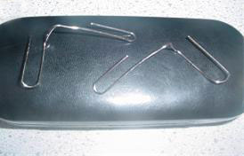
Left Tail
Right Tail
Insulation

Figure 2. Cross section (or side view) of wire.
Figure 3. The bent paperclips.

- Bend the two paper clips to look like those in Figure 3. Use needle-nosed pliers if necessary.
- To ensure good contact at the battery terminals, sand the paper clips lightly on the surfaces that will touch the battery and the surfaces that the coil will rest on.
- Use a rubber band to secure the large loop ends of each paper clip to the terminals of the D-cell battery. The battery, rubber band and paper clips device should look like Figure 4.
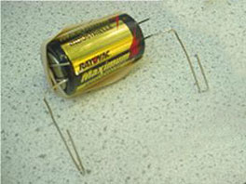
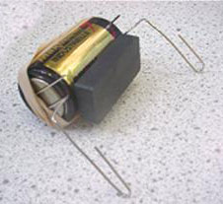

Figure 4. Use a rubber band to secure the paperclips to the battery.
Figure 5. Battery end view, with ceramic magnet in place.

- Place a ceramic magnet on the side of the battery (it will “stick” to the battery) as shown in Figures 5.
- Place the coiled wire with tails into the small loops formed by the unattached ends of the paper clips (“cradles”). Your motor should look like the one in Figure 6.
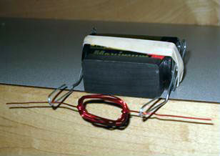

Figure 6. The complete motor setup.

- Turn the coil slowly by hand (only touch the insulated part of the wire) and observe the magnetic attraction and repulsion between the electromagnet and the ceramic magnet.
- (Optional) Remove the magnet from the battery. Use a compass to determine the orientation of the magnetic field of the coil. Remove the coil and replace it on the paper clips in the opposite direction. Use the compass to determine the orientation of magnetic field of the coil again.

Part 2: Making the Motor Do Work
- Position the motor on the edge of a table or countertop (see Figure 6).
- Bend the end of the wire that has the insulation completely removed into a very small, tight loop.
- Tie one end of a one-foot (.3 m) long piece of thread around this loop. Tie the other end around a small paper clip.
- Give the coil a little push to get it to start winding up the string. Once the extra loop and string are added, it may throw the motor off balance. Getting the motor to wrap the string correctly takes a significant bit of tweaking, but it will work. Use your finger as a guide.
- Once the motor picks up one paper clip, unwind it and try connecting a second paper clip to the first. Keep adding paper clips and trying again until the motor is no longer able to lift the load. We were able to lift 16 paper clips with just this motor, so it is possible!
Sources of all images:
Figure 1: Copyright © Ashleigh Bailey, ITL Program, University of Colorado at Boulder, 2006. All rights reserved.
Race car clip art: Copyright © 2004 Microsoft Corporation, One Microsoft Way, Redmond, WA 98052-6399 USA. All rights reserved.
Figure 2: Copyright © Janet Yowell, ITL Program, University of Colorado at Boulder, 2006. All rights reserved.
Figure 3: Copyright © Joe Friedrichsen, ITL Program, University of Colorado at Boulder, 2004. All rights reserved.
Figure 4: Copyright © Joe Friedrichsen, ITL Program, University of Colorado at Boulder, 2004. All rights reserved.
Figure 5: Copyright © Joe Friedrichsen, ITL Program, University of Colorado at Boulder, 2004. All rights reserved.
Figure 6: Copyright © Janet Yowell, ITL Program, University of Colorado at Boulder, 2006. All rights reserved.

