Example Rover (Can you identify the parts?)
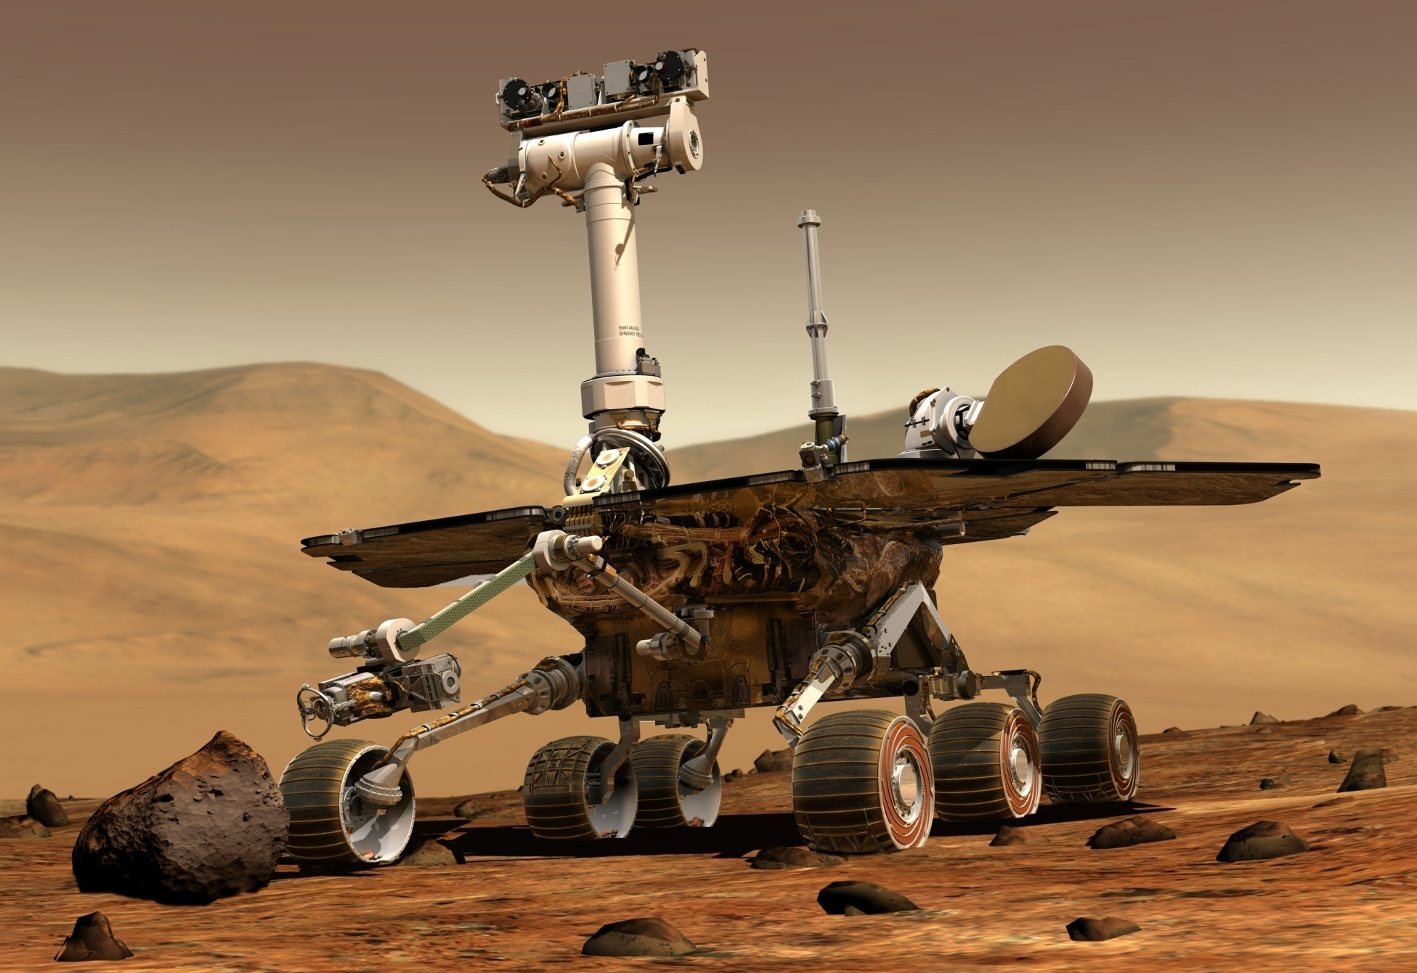

Image source: Courtesy NASA/JPL-Caltech, http://marsrover.nasa.gov/gallery/artwork/hires/rover3.jpg
Mission to Mars, Lesson 3: Edible Rover Activity — Rover Parts Identifier Handout-Overhead 1

Rover Main Parts and Functions
body: protects the rover’s "organs"
brains: computers that process the rover's information
wheels: attached to the legs and allows rover movement
arm: a robotic arm used for extension and movement to use tools and instruments
energy source: solar panels and batteries
cameras: cameras mounted on the head, front or back of the rover to “see” and take pictures
communications: antennae for communication with NASA and Earth
temperature controls: heaters and insulation to protect the rover
instruments and tools, such as:
abrasion tool: scrapes rock to bring back samples
spectrometer: identifies any minerals that contain iron
x-ray spectrometer: takes x-rays of rocks and soil so NASA can identify elements in the rocks
microscopic imager: shows very small details of rocks and soil

Mission to Mars, Lesson 3: Edible Rover Activity — Rover Parts Identifier Handout-Overhead 2

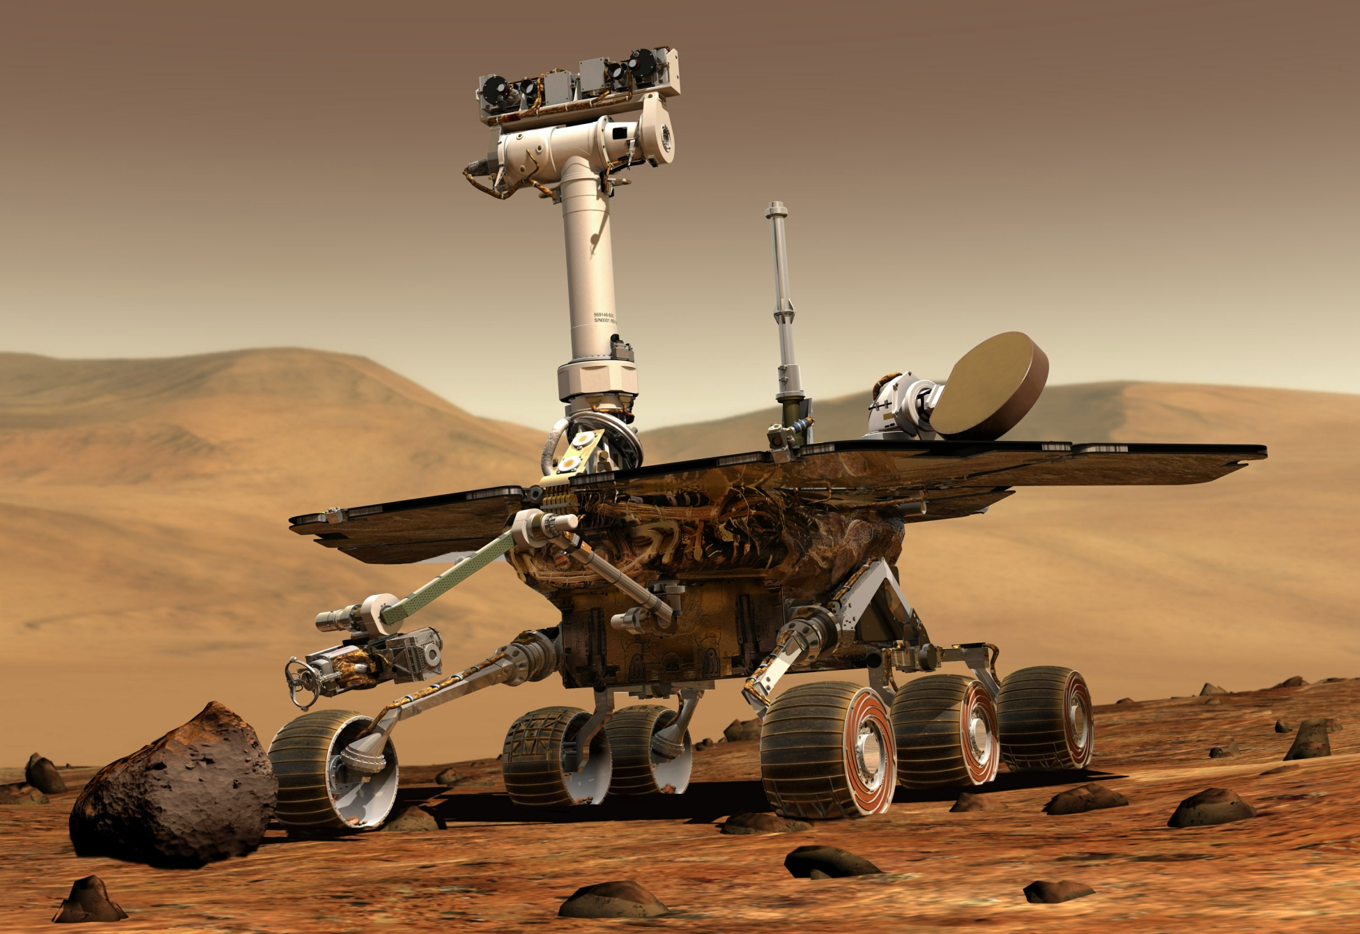
Example Rover with Main Parts Identified
panoramic camera

antennae

energy source
(solar panels)
navigation camera

hazards camera

arm
body
& brains
instruments
& tools

wheels

legs

Image source: Courtesy NASA/JPL-Caltech, http://marsrover.nasa.gov/gallery/artwork/hires/rover3.jpg
Mission to Mars, Lesson 3: Edible Rover Activity — Rover Parts Identifier Handout-Overhead 3

