Mining Worksheet
- Record how many beans you recover during each “work day.”
Work Day | Number of Miners | Pieces Recovered
1 | 1
2 | 1
3
4
5
6
7
8
9
10
11
12
13
14
15
16
17
18
19
20
- How hard was it to extract the resources at first?

- How hard was it to extract the resources in the last time step?

- Graph your data. Graph the number of beans recovered during each “work day.”
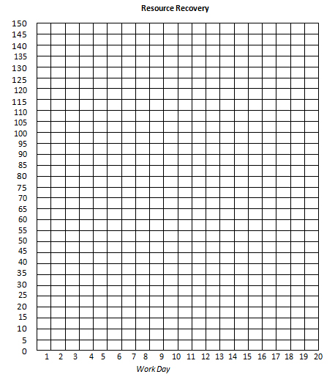

Minerals (Beans) Recovered

- Describe the shape of the graph.

Questions
- What are some disadvantages of using nonrenewable resources?

- How might you conserve resources? (Write a few sentences.)

