Mining Worksheet Answers
- Record how many beans you recover during each “work day.”
Work Day | Number of Miners | Pieces Recovered
1  Example answers: Answers in the chart should be different for each student; an example set is provided. This also gives you a clue as to when to stop mining. Expect all groups to show some decline before you stop. | 1 | 14
2 | 1 | 21
3 |  | 20
4 |  | 25
5 |  | 43
6 |  | 52
7 |  | 116
8 |  | 120
9 |  | 23
10 |  | 9
11 |  | 1
12
13
14
15
16
17
18
19
20
- How hard was it to extract the resources at first?
At first it was very easy to extract resources because many were visible right on top.

- How hard was it to extract the resources in the last time step?
At the end it was very difficult to extract resources because so few were left and the remaining resources were not easy to locate.

- Graph your data:
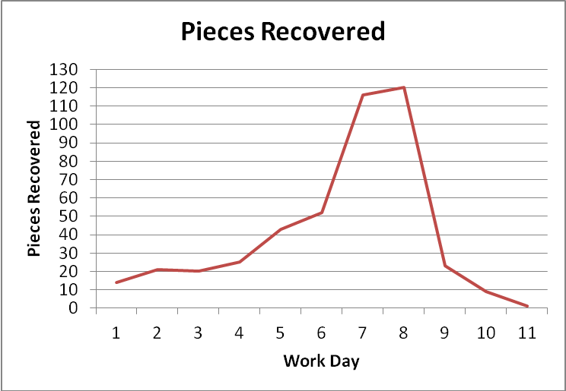

- Describe the shape of the graph.
The graph slowly increases at first, reaches a peak on the eighth day, and then decreases.

Questions
- What are some disadvantages of using nonrenewable resources?
They do not last forever, they become more expensive, they become more difficult to extract.

- How might you conserve resources? (Write a few sentences.)
Expect students to describe different ways they might generate electricity, or how they might use fewer resources by recycling or using less electricity. Example answer: I would conserve resources by recycling more and turning off the TV when no one is watching it. I would also get my parents to buy electricity generated by wind turbines.

