Periodic Table of the Naturally-Occurring Elements
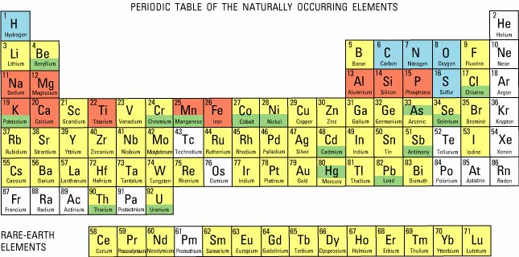

Source: U.S. Geological Survey, http://pubs.usgs.gov/circ/c1143/html/fig9.jpg

