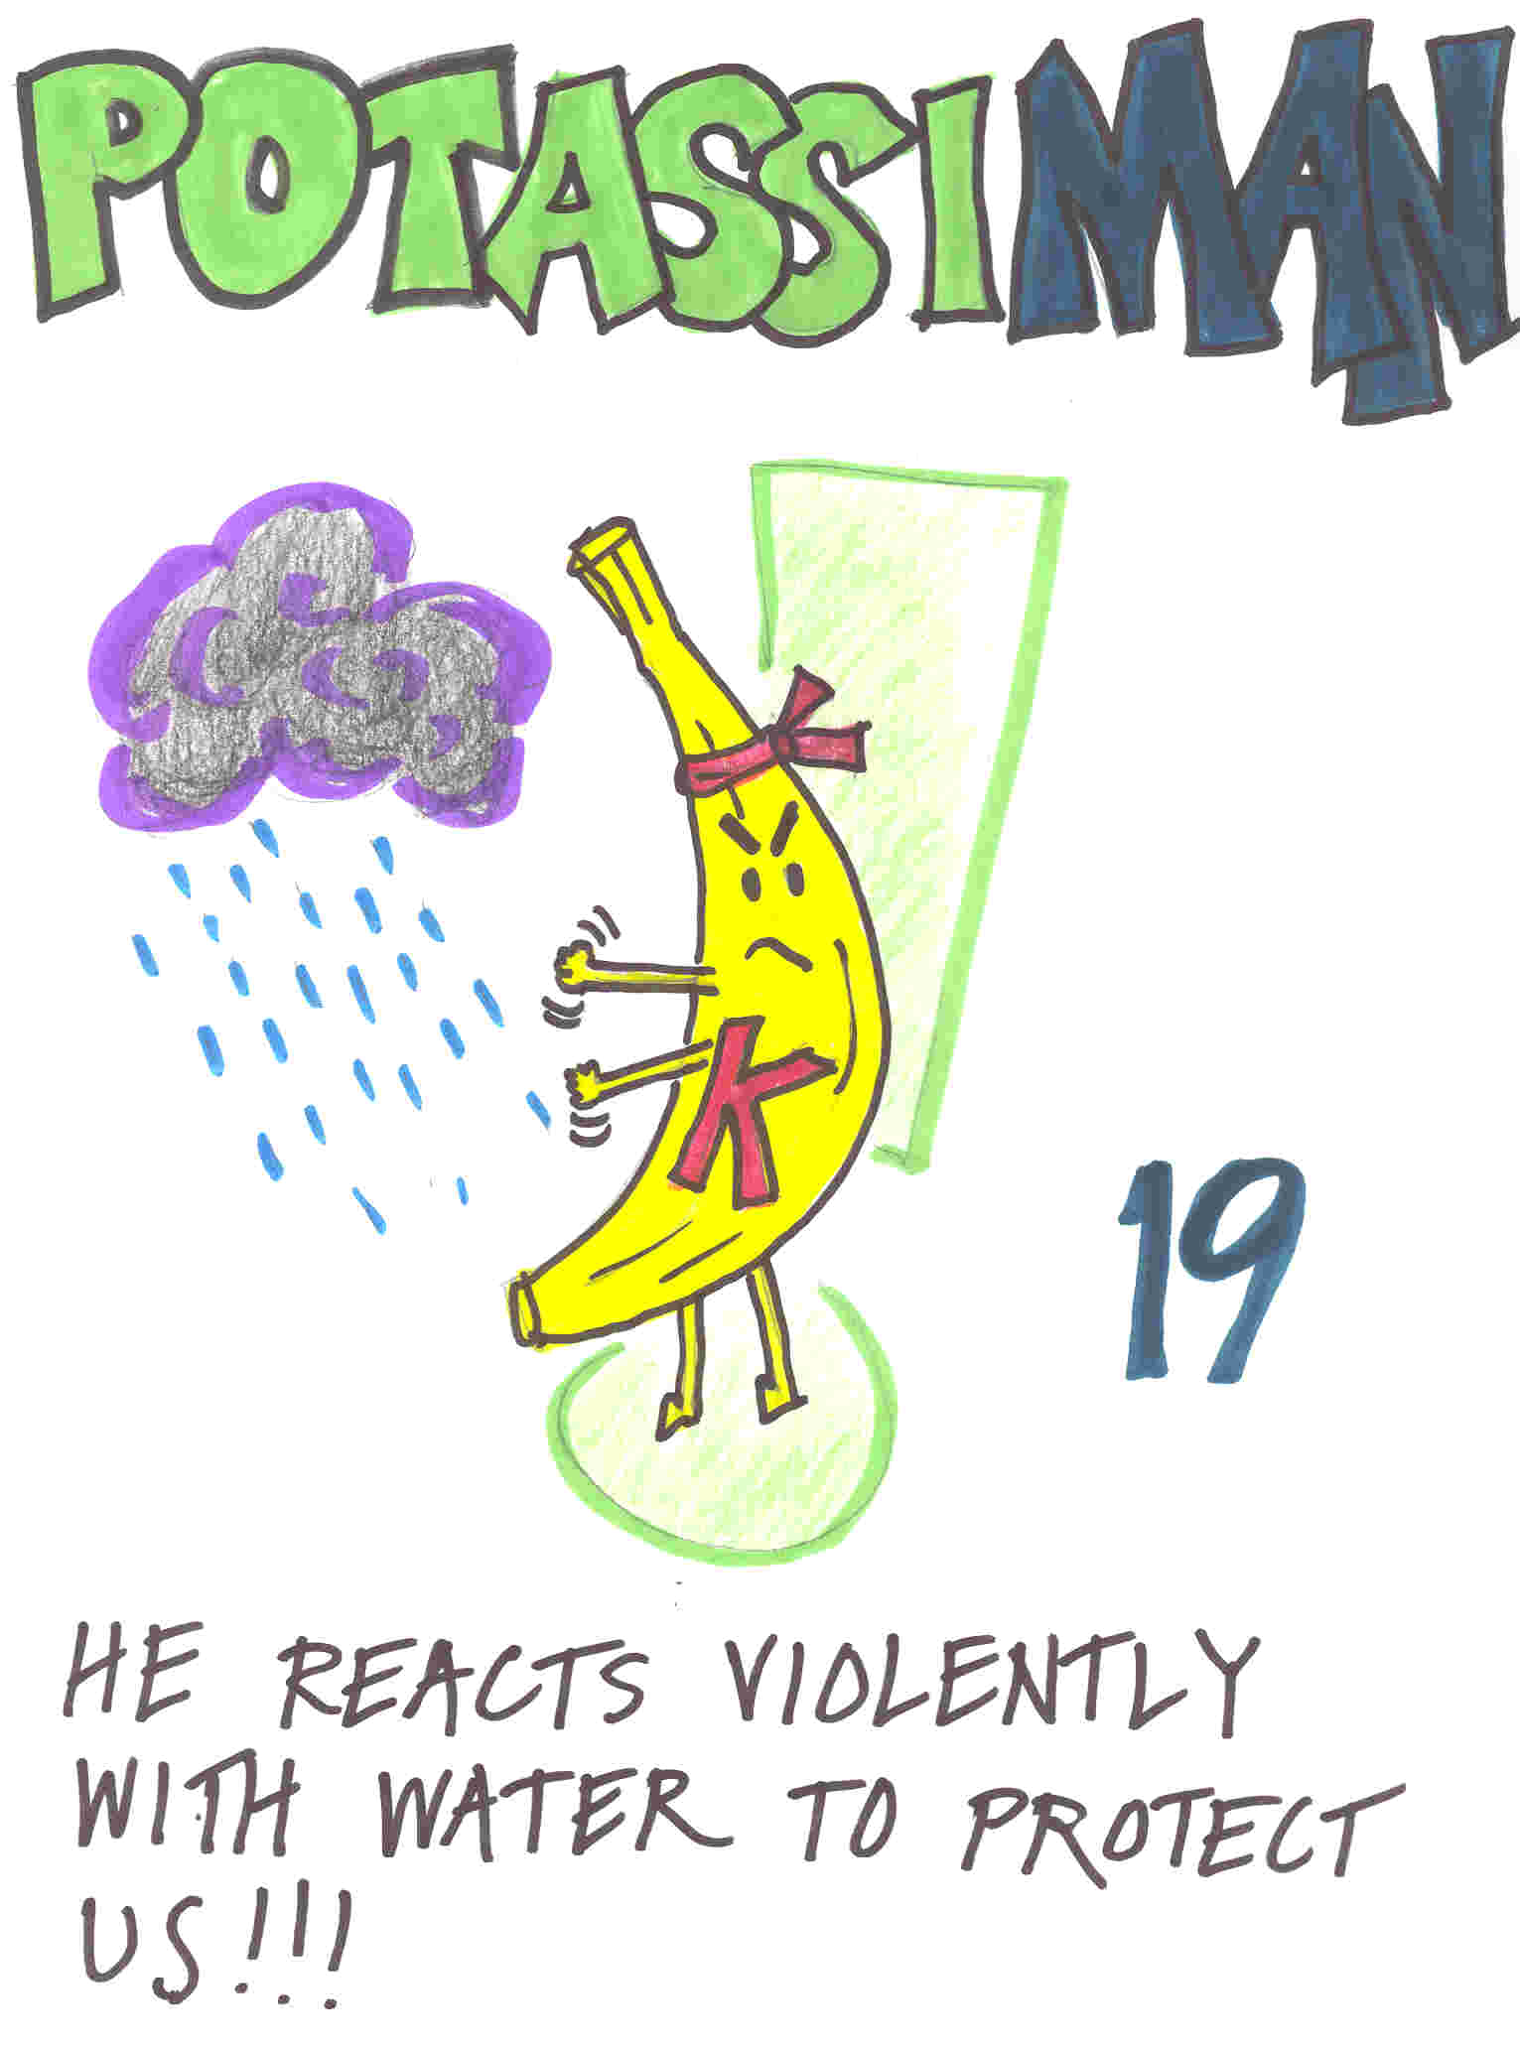
Copyright© Megan Podlogar, College of Engineering, University of Colorado at Boulder.

