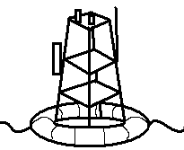  Tsunami Buoy | 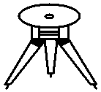  Volcano Monitor | 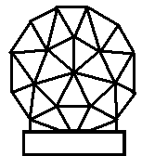  Doppler Radar | 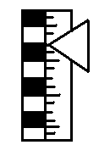  Water Gauge | 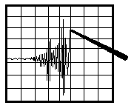  Seismometer | 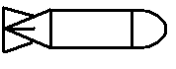  Avalanche Mortar | Tsunami Buoy | Volcano Monitor | Doppler Radar | Water Gauge | Seismometer | Natural Disasters: Lesson 1, Save Our City! Activit — Disaster Prevention Devices Sheet  Avalanche Mortar
Tsunami Buoy | Volcano Monitor | Doppler Radar | Water Gauge | Seismometer | Avalanche Mortar | Tsunami Buoy | Volcano Monitor | Doppler Radar | Water Gauge | Seismometer | Avalanche Mortar
Tsunami Buoy | Volcano Monitor | Doppler Radar | Water Gauge | Seismometer | Avalanche Mortar | Tsunami Buoy | Volcano Monitor | Doppler Radar | Water Gauge | Seismometer | Avalanche Mortar
Tsunami Buoy | Volcano Monitor | Doppler Radar | Water Gauge | Seismometer | Avalanche Mortar | Tsunami Buoy | Volcano Monitor | Doppler Radar | Water Gauge | Seismometer | Avalanche Mortar
Tsunami Buoy | Volcano Monitor | Doppler Radar | Water Gauge | Seismometer | Avalanche Mortar | Tsunami Buoy | Volcano Monitor | Doppler Radar | Water Gauge | Seismometer | Avalanche Mortar
Tsunami Buoy | Volcano Monitor | Doppler Radar | Water Gauge | Seismometer | Avalanche Mortar | Tsunami Buoy | Volcano Monitor | Doppler Radar | Water Gauge | Seismometer | Avalanche Mortar
Tsunami Buoy | Volcano Monitor | Doppler Radar | Water Gauge | Seismometer | Avalanche Mortar | Tsunami Buoy | Volcano Monitor | Doppler Radar | Water Gauge | Seismometer | Avalanche Mortar
Tsunami Buoy | Volcano Monitor | Doppler Radar | Water Gauge | Seismometer | Avalanche Mortar | Tsunami Buoy | Volcano Monitor | Doppler Radar | Water Gauge | Seismometer | Avalanche Mortar
Tsunami Buoy | Volcano Monitor | Doppler Radar | Water Gauge | Seismometer | Avalanche Mortar | Tsunami Buoy | Volcano Monitor | Doppler Radar | Water Gauge | Seismometer | Avalanche Mortar
Tsunami Buoy | Volcano Monitor | Doppler Radar | Water Gauge | Seismometer | Avalanche Mortar | Tsunami Buoy | Volcano Monitor | Doppler Radar | Water Gauge | Seismometer | Avalanche Mortar

