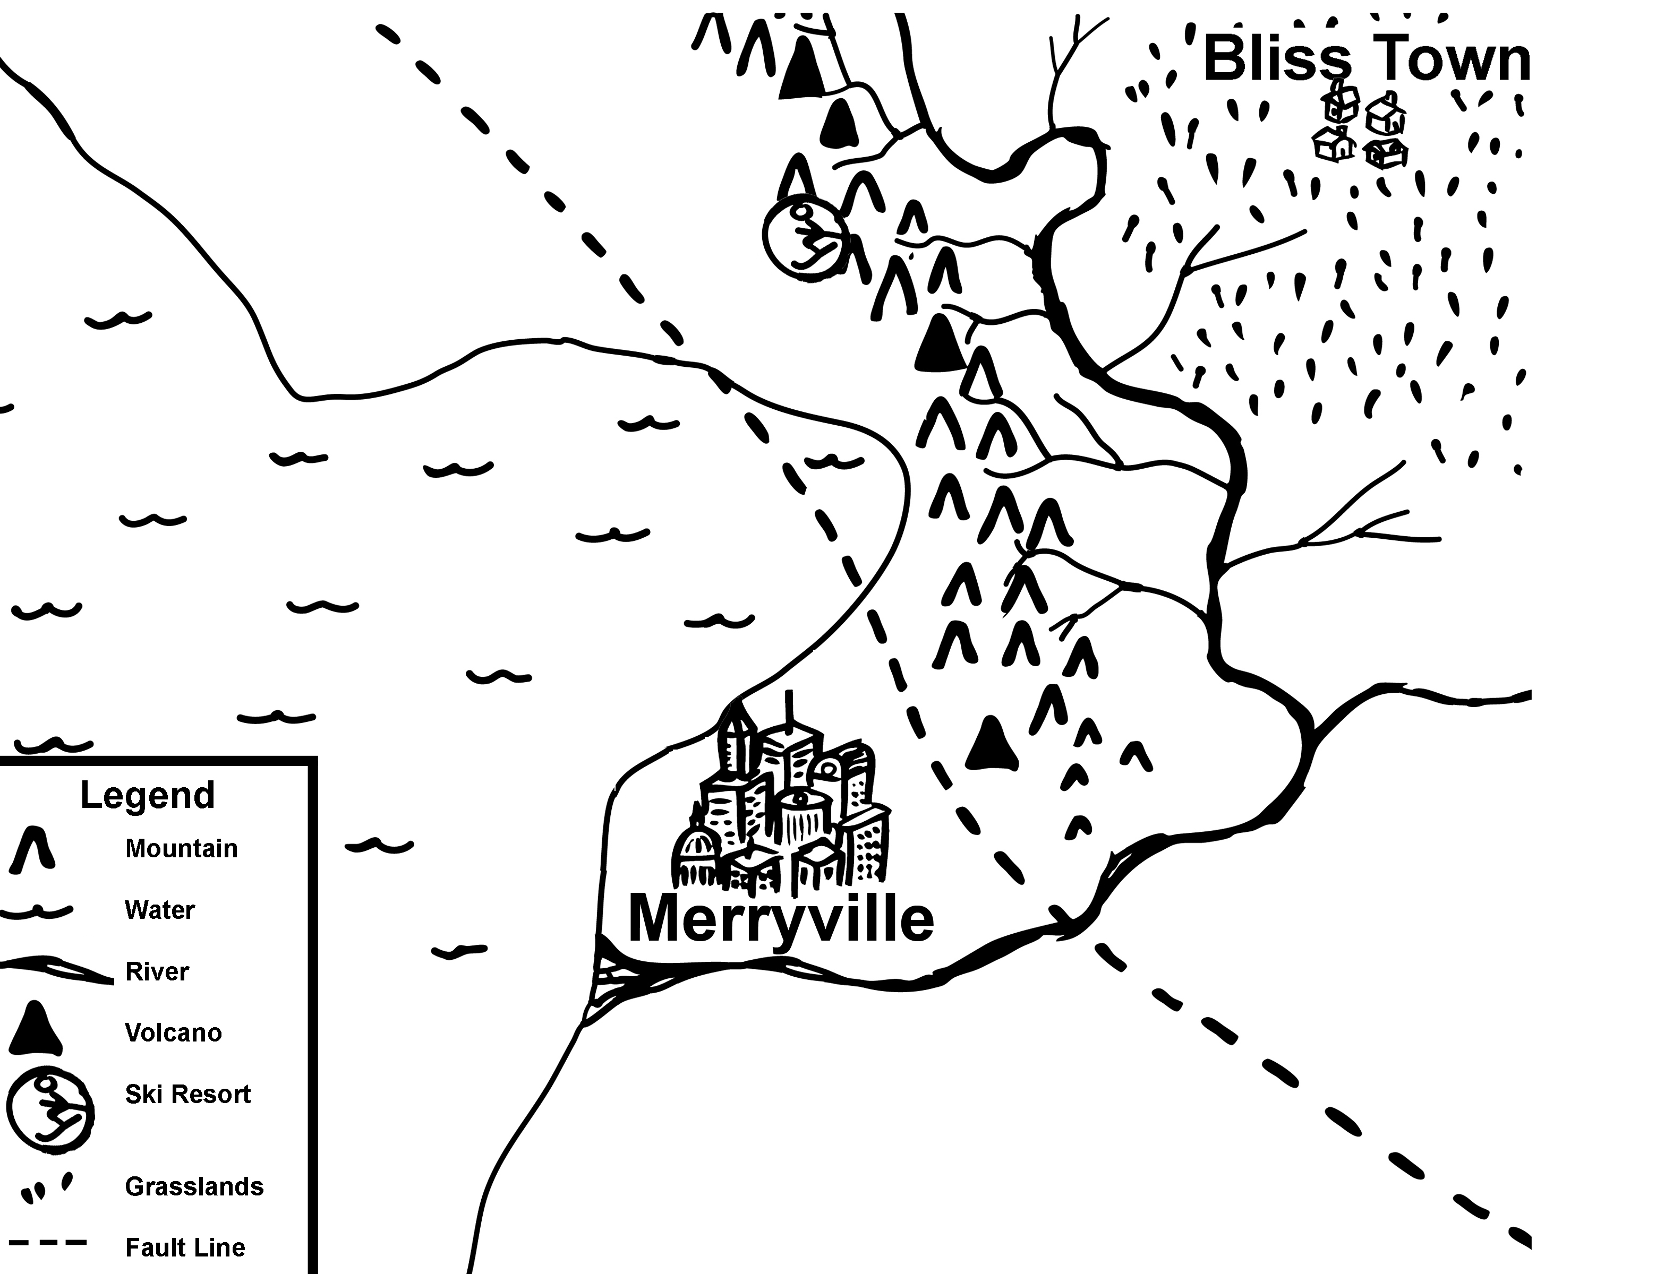
Natural Disasters: Lesson 1, Save Our City! Activity — Map of Unawaria

