Scaling Down the Earth – Math Extension Worksheet

The model Earth you made is known as a scale model. In fact, this model would be called a 1:200,000,000 model, meaning that the clay earth you hold in your hand is 200,000,000 times smaller than the real earth. Knowing what the scale is, we can find the real dimensions of the Earth.

The inner core (red layer) of your clay model is 1 centimeter (cm). The inner core of the Earth is really not 1 cm thick, but 200,000,000 times bigger than that. Therefore, we need to multiply the diameter of the inner core (1 cm) by our scale of 200,000,000 to find the actual diameter of the Earth.

Diameter of Model x Scale = Actual Diameter
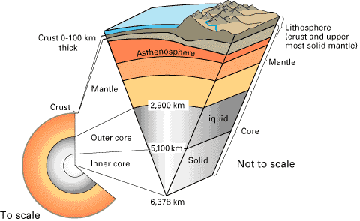
Example:
1 cm x 200,000,000 = 200,000,000 cm

Figure 1. Cut-Away of the Earth
Source: http://pubs.usgs.gov/publications/text/inside.html

Using this example, complete the table below:
 | Total Diameter (cm) | Earth’s Actual Diameter (cm)
Inner Core | 1 | 200,000,000
Outer Core | 3
Mantle | 6
Crust | 6.1

