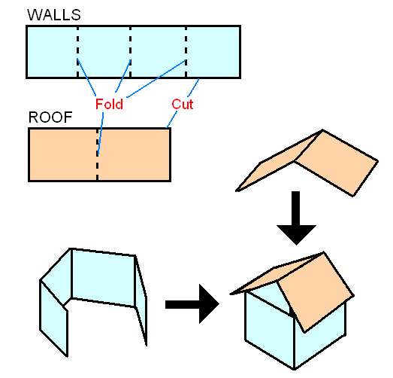
⬅ roof
⬅ walls
⬅ roof
⬅ roof
⬅ roof
⬅ walls
⬅ walls
⬅ walls
Natural Disasters: Lesson 7, Floodplain Modeling Activity — Model House Template




