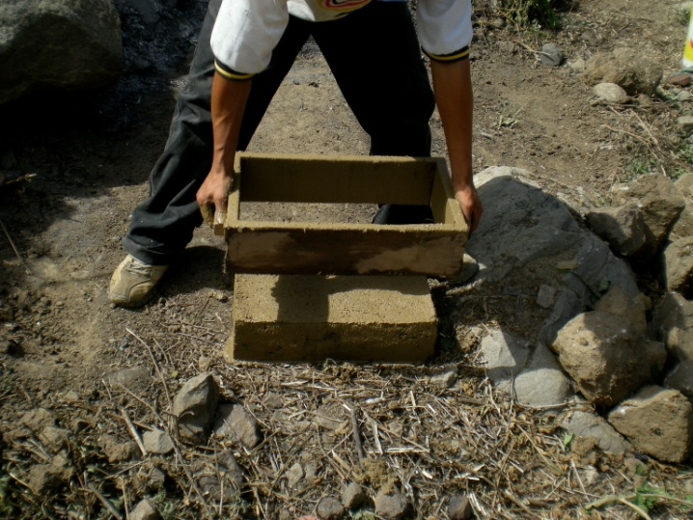
Obi-Wan Adobe Design Worksheet
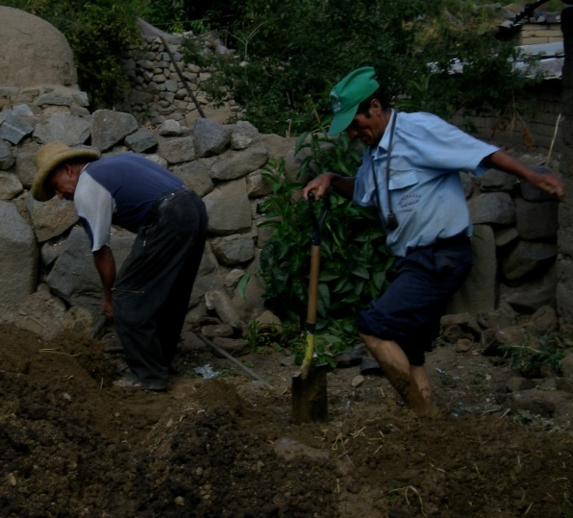

Adobe Brick Construction
- Your teacher will assign one of the following variables for your team to test:
water content, straw content or sand content ←Circle your team’s variable
- For the variable you are assigned, build the three bricks that are described below.
- Carefully measure the ingredients for each brick the SAME way so each brick is exactly the same EXCEPT for the variable being tested.
- Wet the mold with water before you place the brick mixture inside.
- When finished, label each brick on the piece of cardboard with your names and A, B or C.
Variable being tested: Water Content
Brick A |  | Brick B |  | Brick C
Material | # of cups | Material | # of cups | Material | # of cups
Soil | 1 | Soil | 1 | Soil | 1
Sand | 1 1/2 | Sand | 1 1/2 | Sand | 1 1/2
Water | 1/4 | Water | 1/2 | Water | 1
Straw | 1 | Straw | 1 | Straw | 1
Variable being tested: Straw Content
Brick A |  | Brick B |  | Brick C
Material | # of cups | Material | # of cups | Material | # of cups
Soil | 1 | Soil | 1 | Soil | 1
Sand | 1 1/2 | Sand | 1 1/2 | Sand | 1 1/2
Water | 1/2 | Water | 1/2 | Water | 1/2
Straw | 0 | Straw | 1 | Straw | 2
Variable being tested: Sand Content
Brick A |  | Brick B |  | Brick C
Material | # of Cups | Material | # of cups | Material | # of cups
Soil | 0 | Soil | 1 | Soil | 2 1/2
Sand | 2 1/2 | Sand | 1 1/2 | Sand | 0
Water | 1/2 | Water | 1/2 | Water | 1/2
Straw | 1 | Straw | 1 | Straw | 1
Adobe Brick Testing
Record the test results for at least three groups, including your own, in the following chart.
Group: ____________________  Variable: _________________________ |  |  | Group: ____________________  Variable: _________________________
Brick | Drop Height |  | Brick | Drop Height
A |  |  | A
B |  |  | B
C |  |  | C
Group: ____________________  Variable: _________________________ |  | Group: ____________________  Variable: _________________________
Brick | Drop Height | Brick |  | Drop Height
A |  | A
B |  | B
C |  | C

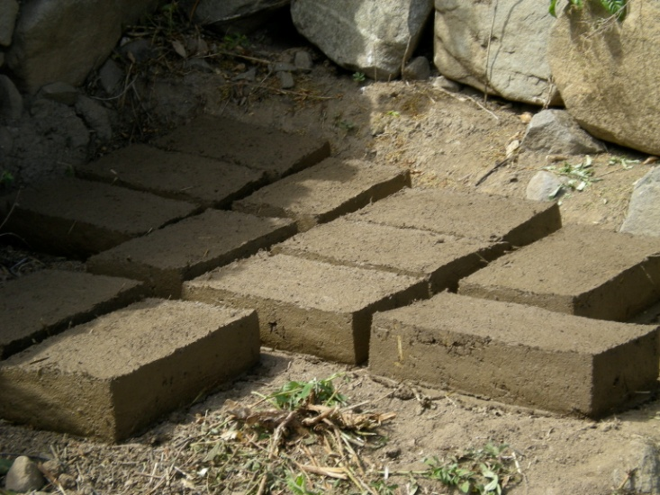

Graphing
Graph the results for each of the three different variables using the data from the tests. See if you can use the graph to figure out the amount of each material that makes the strongest brick.

Graphing (continued)

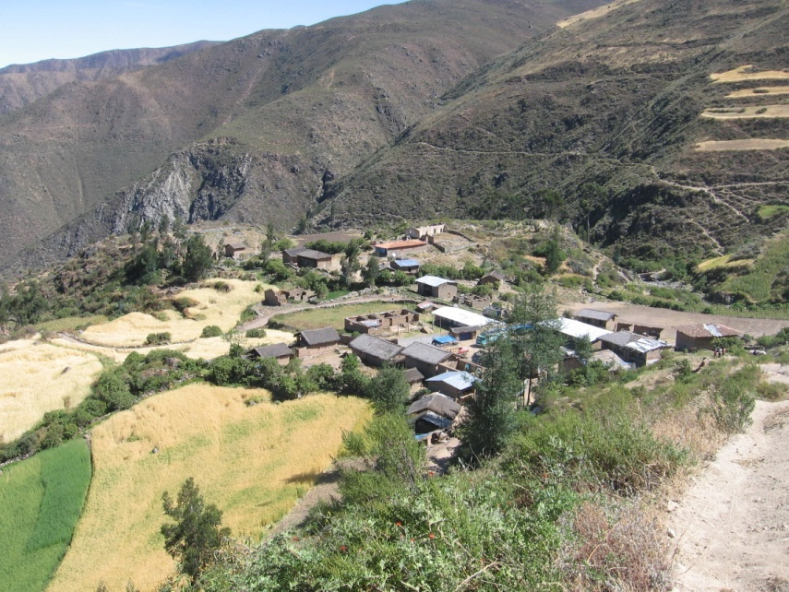
Engineering Challenge
A village in Peru needs your help! They are building a new town center using adobe bricks and need to know how much of each material to include in their brick “recipe” to make them the strongest.
Using the information you learned from your class tests, develop a recipe for the village’s adobe bricks. Include this recipe in the following chart and make a model brick to be tested next class period.
Huaraday, Peru ➔

Model Brick Recipe
Material | # of cups
soil
sand
water
straw

Group Testing
- Record the testing results for each group’s model brick in the following chart.
- Discuss as a class which brick was the strongest and why this may have been the case. Reference the graphs from the previous day, where appropriate.
Group | Drop Height | Sand (cups) | Soil (cups) | Water (cups) | Straw (cups)
1
2
3
4
5
6
7
- What other variables might you have introduced into your experiment that caused two bricks with exactly the same ingredients to have different strengths?
Source of four photos: Jacob P. Crosby, ITL Program College of Engineering, University of Colorado at Boulder.

