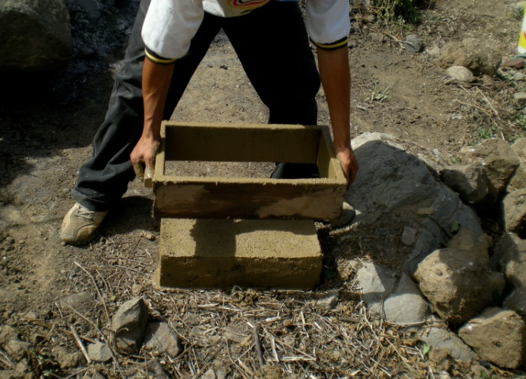
Obi-Wan Adobe Design Worksheet
Example Answers
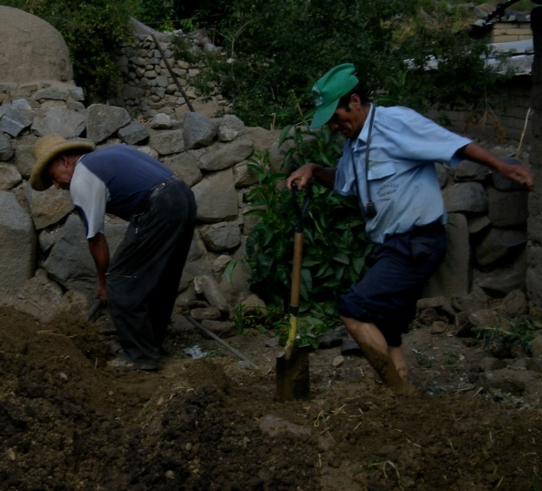

Adobe Brick Construction
- Your teacher will assign one of the following variables for your team to test:
water content, straw content or sand content. ←Circle your team’s variable
- For the variable you are assigned, build the three bricks that are described below.
- Carefully measure the ingredients for each brick the SAME way so each brick is exactly the same EXCEPT for the variable being tested.
- Wet the mold with water before you place the brick mixture inside.
- When finished, label on each brick on the piece of cardboard with your names and A, B or C.
Variable being tested: Water Content
Brick A |  | Brick B |  | Brick C
Material | # of cups | Material | # of cups | Material | # of cups
Soil | 1 | Soil | 1 | Soil | 1
Sand | 1 1/2 | Sand | 1 1/2 | Sand | 1 1/2
Water | 1/4 | Water | 1/2 | Water | 1
Straw | 1 | Straw | 1 | Straw | 1
Variable being tested: Straw Content
Brick A |  | Brick B |  | Brick C
Material | # of cups | Material | # of cups | Material | # of cups
Soil | 1 | Soil | 1 | Soil | 1
Sand | 1 1/2 | Sand | 1 1/2 | Sand | 1 1/2
Water | 1/2 | Water | 1/2 | Water | 1/2
Straw | 0 | Straw | 1 | Straw | 2
Variable being tested: Sand Content
Brick A |  | Brick B |  | Brick C
Material | # of cups | Material | # of cups | Material | # of cups
Soil | 0 | Soil | 1 | Soil | 2 1/2
Sand | 2 1/2 | Sand | 1 1/2 | Sand | 0
Water | 1/2 | Water | 1/2 | Water | 1/2
Straw | 1 | Straw | 1 | Straw | 1
Adobe Brick Testing
Record the test results for at least three groups, including your own, in the following chart.
This is example experimental data. Your class’ data may vary considerably among groups, depending on the procedure they followed when making their bricks. Discuss this after the experiment to reinforce the variables idea.

Group: 1  Variable: water content |  |  | Group: 2  Variable: sand content
Brick | Drop Height |  | Brick | Drop Height
A | 5 ft |  | A | 0.5 ft
B | 8 ft |  | B | 6 ft
C | 7 ft |  | C | 8 ft
Group: 3  Variable: straw content |  | Group: 4  Variable: water content
Brick | Drop Height | Brick |  | Drop Height
A | 6.5 ft | A |  | 4 ft
B | 8 ft | B |  | 10 ft
C | 6.5 ft | C |  | 6 ft

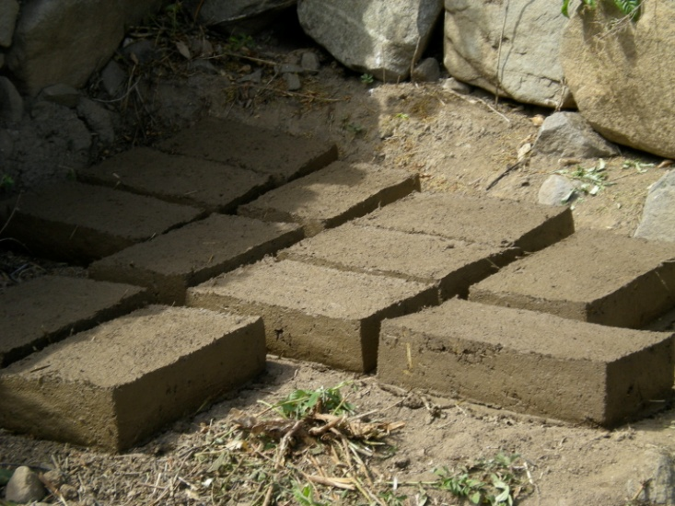

Graphing
Graph the results for each of the three different variables using the data from the tests. See if you can use the graph to figure out the amount of each material that makes the strongest brick.

Sample Graph: Water Content vs. Brick Strength

Sample Graph: Sand Content vs. Brick Strength

Sample Graph: Straw Content vs. Brick Strength

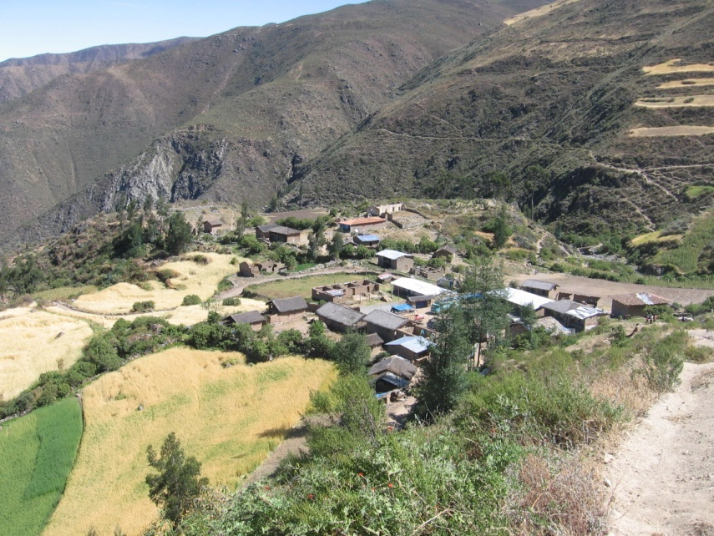
Engineering Challenge
A village in Peru needs your help! They are building a new town center using adobe bricks and need to know how much of each material to include in their brick “recipe” to make them the strongest.
Using the information you learned from your class tests, develop a recipe for the village’s adobe bricks. Include this recipe in the following chart and make a model brick to be tested next class period.
Huaraday, Peru ➔

Model Brick Recipe
Material | # of cups
soil | 2 1/4
sand | 1/4
water | 3/4
straw | 1

Example brick recipe ➔
(may not be the best recipe for your soil type)

Group Testing
- Record the testing results for each group’s model brick in the following chart.
- Discuss as a class which brick was the strongest and why this may have been the case. Reference the graphs from the previous day, where appropriate.
Group | Drop Height | Sand (cups) | Soil (cups) | Water (cups) | Straw (cups)
1 | 11 ft | ¼ | 2 ¼ | ¾ | 1
2 | 10 ft | 0 | 2 ½ | ½ | 3/4
3 | 8 ft | ½ | 2 | 1 | ½
4 | 9 ft | ¼ | 2 ¼ | ¾ | 1
5 | etc.
6
7
- What other variables might you have introduced into your experiment that caused two bricks with exactly the same ingredients to have different strengths?
Example answers:
- The original moisture content of the sand.
- The original moisture content of the soil.
- Student measurement techniques.
- Student mixing techniques.
- Drying condition of the bricks (weather, position, etc.).
- Type of clay soil used.
- Type of fibrous material used (size, composition, etc.).
- How material was compacted into mold and removed (amount of packing, etc.).
- Testing technique. Etc.
Source of four photos: Jacob P. Crosby, ITL Program College of Engineering, University of Colorado at Boulder.

