Ice, Ice PV!
Investigation Worksheet Answers
Data Collection
Record the measurements from the experiment in the tables, below. Measure the voltage and current under ambient conditions before the ice bath. Calculate the power at each time after the experiment is completed using the electrical power equation. Use the current measured at ambient conditions to calculate power for all times.
Ambient Conditions
Temperature, T (ºC)  example answers | 25
Current, I (A) | .108
Voltage, V (V) | 5.78
Power, P (W) | 0.624

Time (min) | Voltage (V) | Power (W) |  | Time (min) | Voltage (V) | Power (W)
0 | 6.78 | 0.732 |  | 8.0 | 5.71 | 0.617
0.5 | 6.56 | 0.709 |  | 8.5 | 5.69 | 0.614
1.0 | 6.40 | 0.691 |  | 9.0 | 5.67 | 0.612
1.5 | 6.26 | 0.676 |  | 9.5 | 5.65 | 0.611
2.0 | 6.16 | 0.665 |  | 10.0 | 5.64 | 0.609
2.5 | 6.11 | 0.660 |  | 10.5 | 5.62 | 0.607
3.0 | 6.07 | 0.656 |  | 11.0 | 5.61 | 0.606
3.5 | 6.01 | 0.649 |  | 11.5 | 5.60 | 0.605
4.0 | 5.97 | 0.645 |  | 12.0 | 5.59 | 0.604
4.5 | 5.92 | 0.640 |  | 12.5 | 5.58 | 0.602
5.0 | 5.89 | 0.636 |  | 13.0 | 5.57 | 0.602
5.5 | 5.85 | 0.632 |  | 13.5 | 5.56 | 0.600
6.0 | 5.82 | 0.629 |  | 14.0 | 5.55 | 0.599
6.5 | 5.79 | 0.625 |  | 14.5 | 5.54 | 0.599
7.0 | 5.76 | 0.622 |  | 15.0 | 5.54 | 0.598
7.5 | 5.73 | 0.619 |  | 15.5 | 5.53 | 0.599

Graphing
Plot the power with respect to time in the graph below.
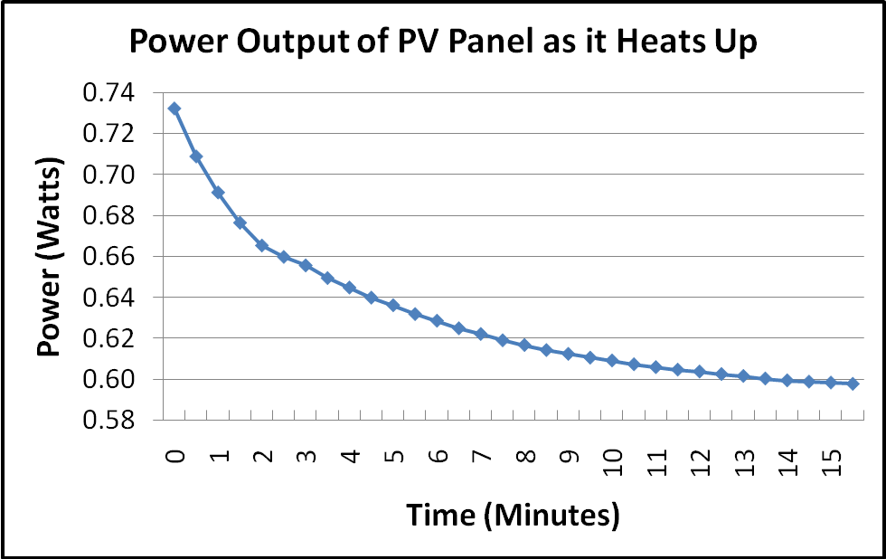

Equations
- Electrical Power Equation
P = power, I = current, V = voltage

- 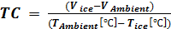 Temperature Coefficient
TC = temperature coefficient, V = voltage, T = temperature

- 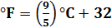 Temperature Conversion
ºC = degrees Celsius, ºF = degrees Fahrenheit

Investigating Questions
- Is the panel more efficient when it is colder or hotter?
With all other conditions the same, the panel has a higher power output when the temperature of the panel is colder, so it is more efficient when it is colder.
- Predict the power output of the panel if left in these experimental conditions indefinitely.
The power output for the experimental conditions seem to level out and approach a value around 5.54V, which gives it a power output of .598 W. (The plot shows this very clearly; the bottom of the diamonds are all just below 0.6 W at the end. )
- Describe the shape of the curve in the graph and why it looks this way.
The plot of the power output vs. time shows the power output of the panel changing by larger amounts early and then, in the end, it barely changes at all. This is most likely because the panel temperature is changing by large amounts in the beginning because it is very cold, but near the end the temperature is changing very little because the panel is approaching its set point temperature for the experimental conditions (the air cools it as much as the light heats it). From this plot we know that the power output is definitely related to the temperature of the panel!
Calculations
- Using Equation 2, find the temperature coefficient (TC) of the panel. Use the initial voltage measured when the lamp is turned on as V_{Ambient} and the first reading after the ice bath as V_{ice}. T_{Ambient} = the room temperature (°C), T_{ice} = 0 °C
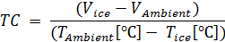
→ 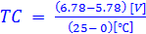
→ 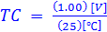
→ 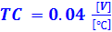
- What are the units of the temperature coefficient?
This means that for every 1 ºC, the voltage changes by 0.04 V

- Using Equations 2 and 3, calculate the temperature of the panel at the time when you recorded the last voltage reading. Your answer should be in °F.

First we manipulate Equation 2 so is by itself on the left.
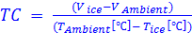
→
→
→
The ambient temperature has changed because of the heating from the lamp. Let’s use the last voltage recording as the new to find the panel temperature at the end of the experiment.
→ 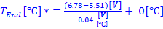
→ 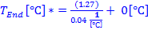 Voltage cancels
→
Now let’s use Equation 3 to convert from to .
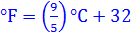
→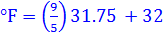
→
→
- Explain what the temperature coefficient means and how it can be used to predict the power output of the panel at any temperature?
The temperature coefficient tells us how much the voltage changes for a 1º change in panel temperature. For our panel, every 1 ºC rise relates to a Voltage drop of 0.04 V. Knowing this, we can calculate what the voltage output of the panel will be at any temperature. If the temperature of the panel changes from 0 ºC to 1 ºC, then the voltage will drop by .04 V. If it changes to 100 ºC, then the voltage will drop by (.04 * 100) V or 4 V. Knowing the voltage of the panel, and assuming nothing else has changed, we can use the same current, and use Equation 1 to calculate the power output at the new temperature.
Calculation # 5 gives us the opportunity to do this for some temperature scenarios that we might encounter in the real world…
- What would the power output of the panel be at the following temperatures? Using Equation 2, replace the ambient temperature with the temperature listed below and solve for the new voltage. Use Equation 1 to calculate the power output.
Description | T (°C) | Voltage | P (W)
Brrrrrr! | -100 | 10.78 | 1.164
Fargo, ND | -28.9 | 7.936 | 0.857
Water freezes | 0 | 6.78 | 0.732
Las Vegas, NV | 41 | 5.14 | 0.555
Water boils | 100 | 2.78 | 0.300
This is similar to Calculation # 3 except we want to isolate the voltage instead of the temperature:
→
→
For water freezes 0 …
→
For Las Vegas, 41 …
→
For Fargo, -28.9 …
→
And so on…
- Calculate the difference in the power output of the panel for the temperatures in Las Vegas and Fargo? What would be the difference in power output if there were a solar PV power plant with 10,000 of these panels installed?
A larger, more efficient solar panel might produce between 200 and 300 Watts. If a 250-W panel’s power output dropped by 35%, as these small ones have between Las Vegas and Fargo temperatures, that would mean a power plant of 10,000 panels would have a difference of around 880 kW! That is a lot.

