Pointing at Maximum Power for PV!
Investigation Worksheet
Data Collection
Follow instructions in the Student Investigation Guide and record your data in the table, below.
Table 1: PV Panel Data Collection
Trial # | Collected Data |  | Calculated
Trial # | Voltage (V) | Current (A) | Power (W)
1
2
3
4
5
6
7
8
9
10
11
12
13
14
15
16
17
18
19
20
21
22

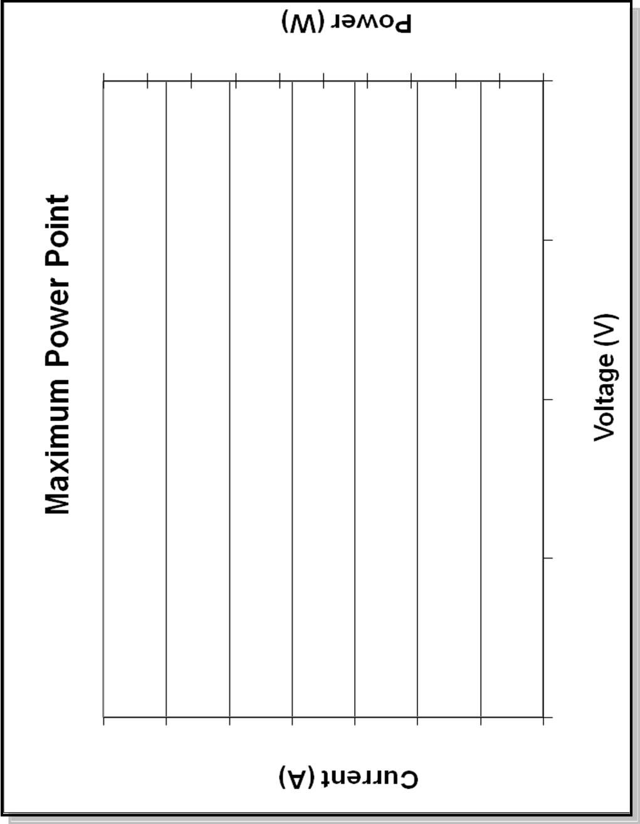

Post-Experiment Assignment
- Calculate power (voltage * current) for each reading and record it in the table.
- Graph current and power vs. voltage on the graph provided. Voltage is on the x-axis, current is on the left y-axis. Power is on the right y-axis. For each variable, create a range on the axis that fits all of the data points. (Note: This looks similar to the Fundamentals Article graph.)
- On the graph, identify the maximum power point, short circuit current (I_{sc}), and open circuit voltage (V_{oc}).
Investigation Questions
  - What was the maximum power produced by your panel?

  - What is the short circuit current (I_{sc}, or current when V=0), and open circuit voltage (V_{oc}, or voltage when I=0) of your PV circuit?

  - Do you think a PV panel produces the same amount of power in different weather conditions? Why or why not?

  - Would it be more efficient for a large field of PV panels (like the one in the photo on page 1of the guide) to have one MPP tracker for the entire field, or to use many MPPTs for smaller areas of the field? Why or why not?

  - If a cloud covered your panel and lowered the current in the circuit, what would happen to the maximum power point? Would it be necessary to adjust the resistance to find a new MPP?

