Permeable Pavement Activity – Community Engineering Post-Assessment Worksheet

A town called New Community has a river that runs through the middle of it. New Community would like your engineers to design a path along the riparian area of the river for people to walk and bike along.
They want a path that meets the following needs:
- Absorbent
- Low cost
- Low maintenance
Using the chart below, draw a design on the map that will work for New Community. (You can use one or more materials.) Then answer questions 1 and 2.
 | Needs
Material | Absorbent | Cost | Maintenance
Dirt/sand | High | Medium | High
Pavement | Low | Medium | Low
Permeable pavement | High | High | Medium
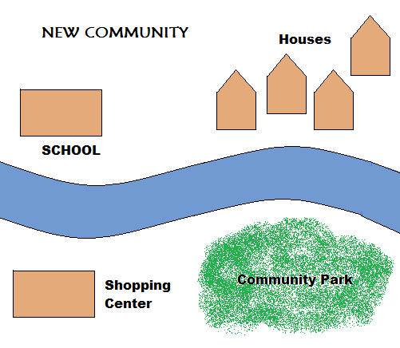

- Explain your design:

- Did you have to decide which need was more important than another? Which did you choose and why?

