Area and Volume Worksheet Example Answers
Answer the following questions about your original object and your scale model. Show your work and include units for all answers. If you use an equation, make sure to show that as well.
- What is the volume of your original object?
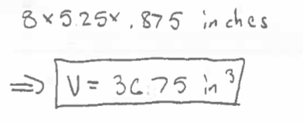

- What is the surface area of your original object?
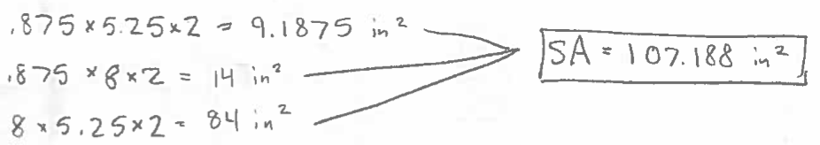

- Based on the relationships we found in class and your scale factor, what is the volume of your model? What is the surface area?
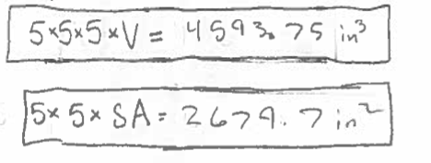

- Check your answer from Question 3. What is the volume of your model using the equation?
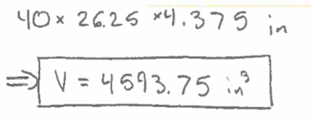

- Check your answer from Question 3. What is the surface area of your model using the equation?
