Quiz Answers
- Engineers do which of the following:
  - Create products for the benefit of society
  - Design based on principles of math and science
  - Created everything we use on a day-to-day basis
  - All of the above
  - None of the above
- A degree in engineering could allow you to:
  - Go to medical school
  - Go to law school
  - Work in exciting job markets
  - All of the above
- For most products, engineers only go through the engineering design process once.
True False
- It is not important for engineers to be able to communicate their ideas to the public.
That’s the job of public relations people.
True False
- During brainstorming, a team should:
  - Avoid crazy ideas and focus on what is reasonable
  - Build on each others ideas
  - Not judge the ideas
  - All of the above
  - B and C only
- Increasing the current flowing through a light bulb will:
  - Make the bulb brighter
  - Make the bulb dimmer
  - Not make a difference
- Calculate the current flowing through Lamp A if each bulb
as a resistance of 1 Ohm and the battery has a voltage of 12 V.
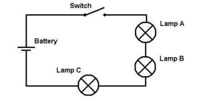
  - 3 Amps
  - 4 Amps
  - 6 Amps
  - 12 Amps
calculation: 12 ÷ (1 + 1 + 1) = 4

