Fluid Dynamics Basics

Bernoulli’s Equation
A very important equation in fluid dynamics is the Bernoulli equation. This equation has four variables: velocity (), elevation (), pressure (), and density (). It also has a constant (), which is the acceleration due to gravity. Here is Bernoulli’s equation:
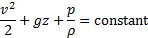
To understand and use this equation, we must know about streamlines. Streamlines are curves that are tangent to the velocity vector of the flow. In other words, they show the direction a fluid element will travel in at any point in time. A streamline is best illustrated by examples: If you throw a leaf in a stream of water, a streamline is the path of the leaf as it floats downstream. Of course the leaf can take any number of paths depending on where it lands in the stream after it was thrown. Streamlines exist underwater as well. Imagine a submerged particle that is neutrally buoyant (meaning it neither sinks nor floats). The particle, such as a waterlogged twig, also follows a streamline down the river.
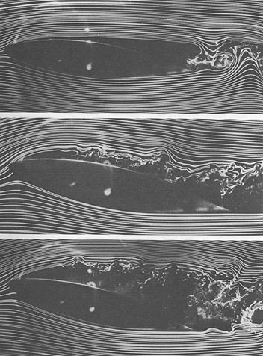
Streamlines can also be visualized with dye in water or smoke in air: See Figure 1.

Figure 1. Streamlines of smoke around an airplane wing in a wind tunnel.
(Image source: NASA, http://history.nasa.gov/SP-4103/app-f.htm)
When values for velocity, pressure, etc. are plugged into Bernoulli’s equation, the result of the equation will be the same (constant) at every point along the streamline.
Take, for example, a water reservoir at the top of a hill. Imagine a streamline from the reservoir to a residence, where the water is used. At the reservoir, the velocity of the water is very small as it slowly moves toward the spillway. For a water particle near the surface of the reservoir, the pressure is also very small. The elevation above the residence, however, is quite large. Let’s plug some of these values into Bernoulli’s equation:
velocity, = 0.01
elevation, = 1000 m
pressure, = 1 Pa
density of water, = 1000 .
acceleration due to gravity, = 9.8
Questions:
- What is the value of Bernoulli’s equation with these values?
- What are the units of this value?
- Which of the following has the biggest effect on the value of Bernoulli’s equation for this case: velocity, elevation, or pressure?
Now let’s follow a particle of water as it leaves the reservoir. As it travels over the spillway and down toward the residence, the elevation decreases, the velocity increases, and if the water travels in an enclosed piping system, the pressure increases. Let’s use Bernoulli’s equation to find the pressure of the water half-way down toward the residence. We’ll assume that we are traveling along the same streamline and that there are no energy losses along the way (more on this later).
Questions:
- What is the value of Bernoulli’s equation at an elevation of 500 m?
- If we measure the speed of the water to be 10 at 500 m of elevation, what is the pressure?
At the end of our journey, the water particle has reached the residence where it is sitting stationary in a faucet, ready to be used by the resident.
Question:
- What is the pressure of the water in the faucet, again assuming the particle has traveled along the same streamline throughout the journey and also assuming no energy loss along its journey?

Head Loss
In reality, the actual water pressure at the faucet would be much, much less than 9.8 MPa. The reason for this is due to head loss, which is energy in a moving fluid that is lost due to friction and turbulence in the water as it travels from the reservoir to the residence. Head loss is associated with the length, diameter, and smoothness of the pipe, bends, fittings, and valves.
Turbulence is one fluidic phenomenon that causes head loss. Turbulence is a fluidic region where the particles that make up the fluid are chaotic or random in motion. Turbulence is seen in Figure 1in the region behind the wing. In the turbulent zone, the streamlines are continually and quickly changing shape and direction so that they are unrecognizable. Turbulent zones take energy from the fluid and contribute to head loss. Engineers try to minimize turbulence in piping systems in order to reduce the amount of energy required to move fluid through the piping system. Despite these efforts, all fittings in piping systems such as valves, tees, and unions cause turbulence. Head loss from this turbulence can be estimated for a fitting if the velocity () of the water is known. Head loss is also dependent on the type of fitting. The following equation and table can be used to estimate head loss from fittings (). Note that the acceleration of gravity constant () in the following equation.
Head loss,
Type of Fitting | Image | ξ (Loss coefficient)
tee, line flow | 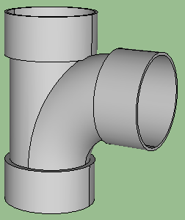  Flow | 0.2
tee, branched flow | Flow | 1.0
elbow, regular 90º | 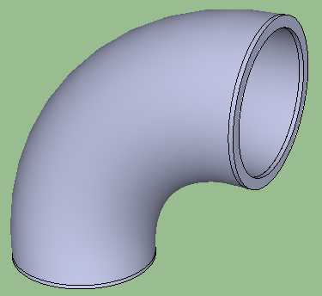 | 0.3
elbow, long radius 90º | 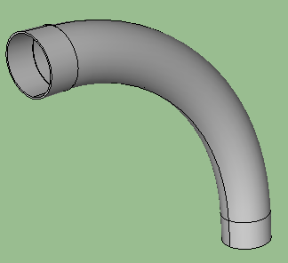 | 0.2
elbow, long radius 45º | 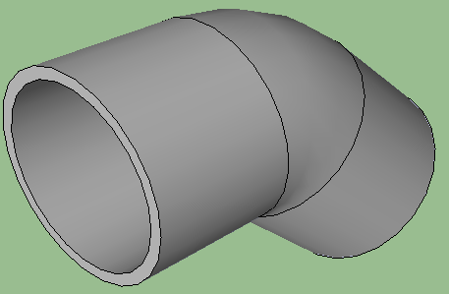 | 0.2
return bend, 180º | 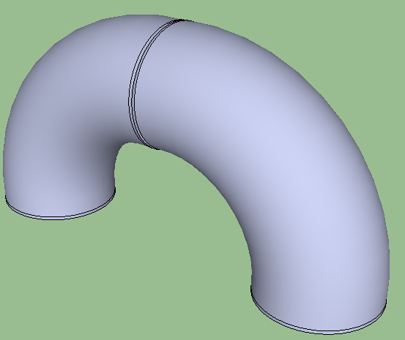 | 0.2
globe valve, fully open | 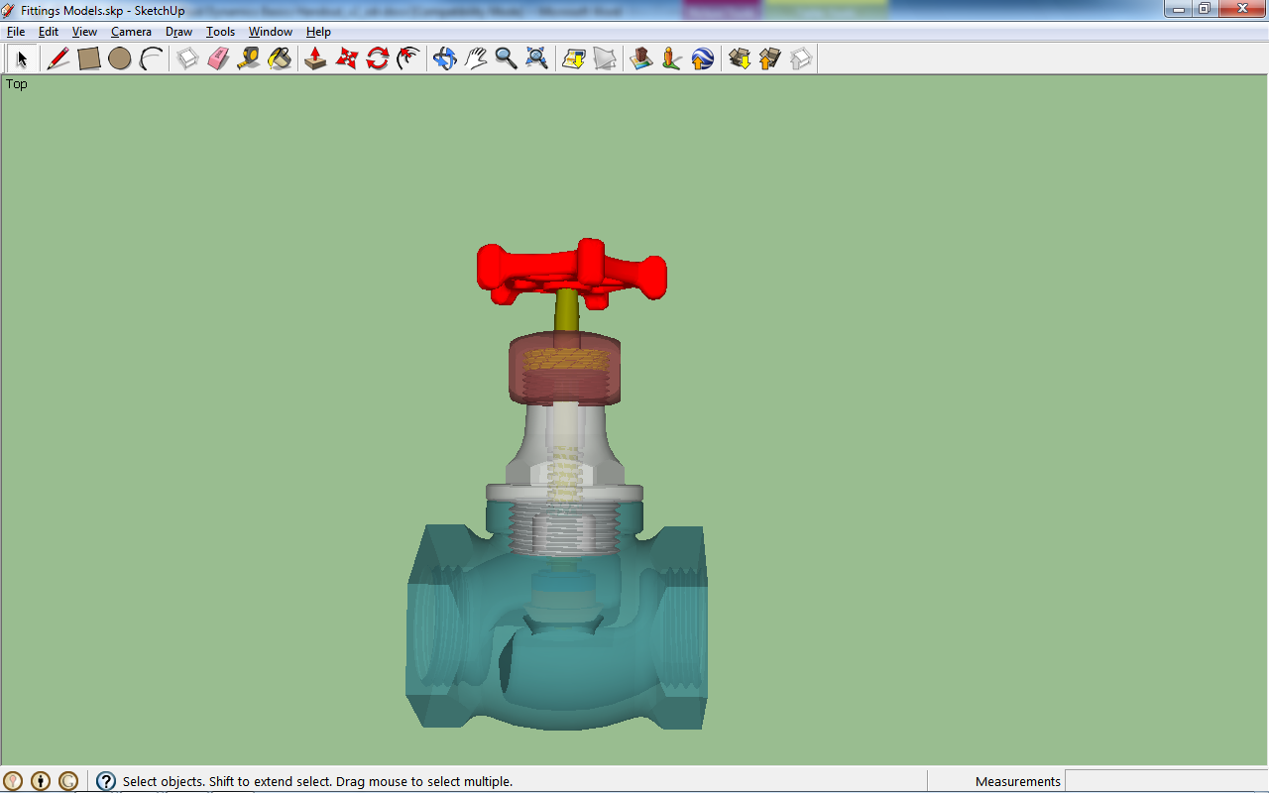 | 10
gate valve, fully open | 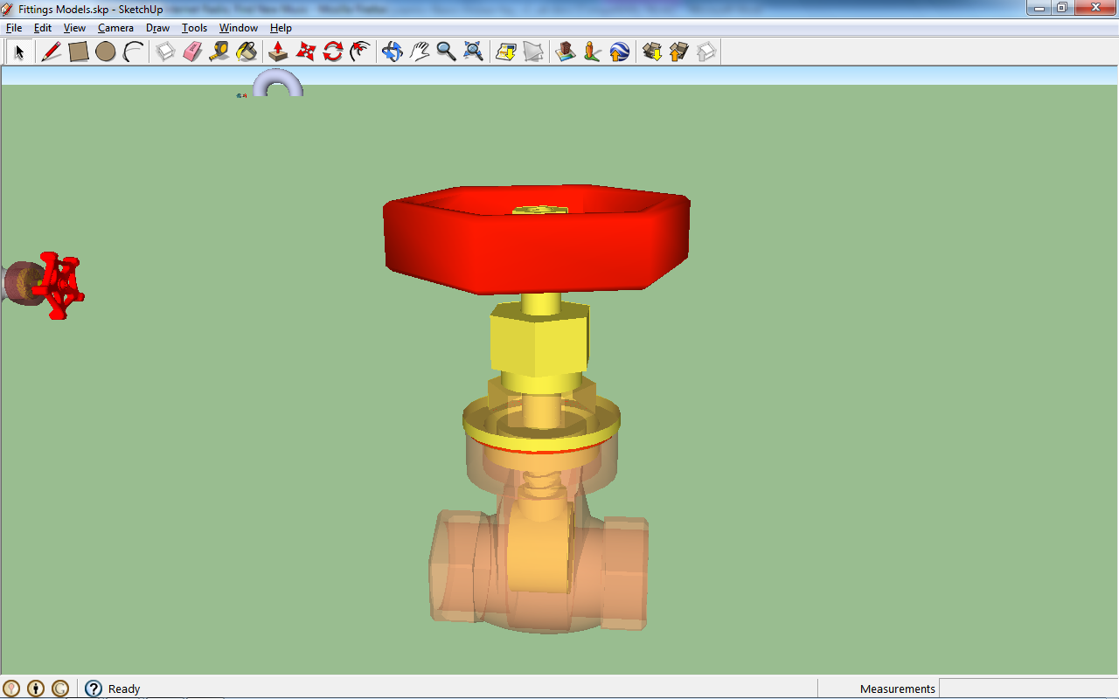 | 0.15
ball valve, fully open | 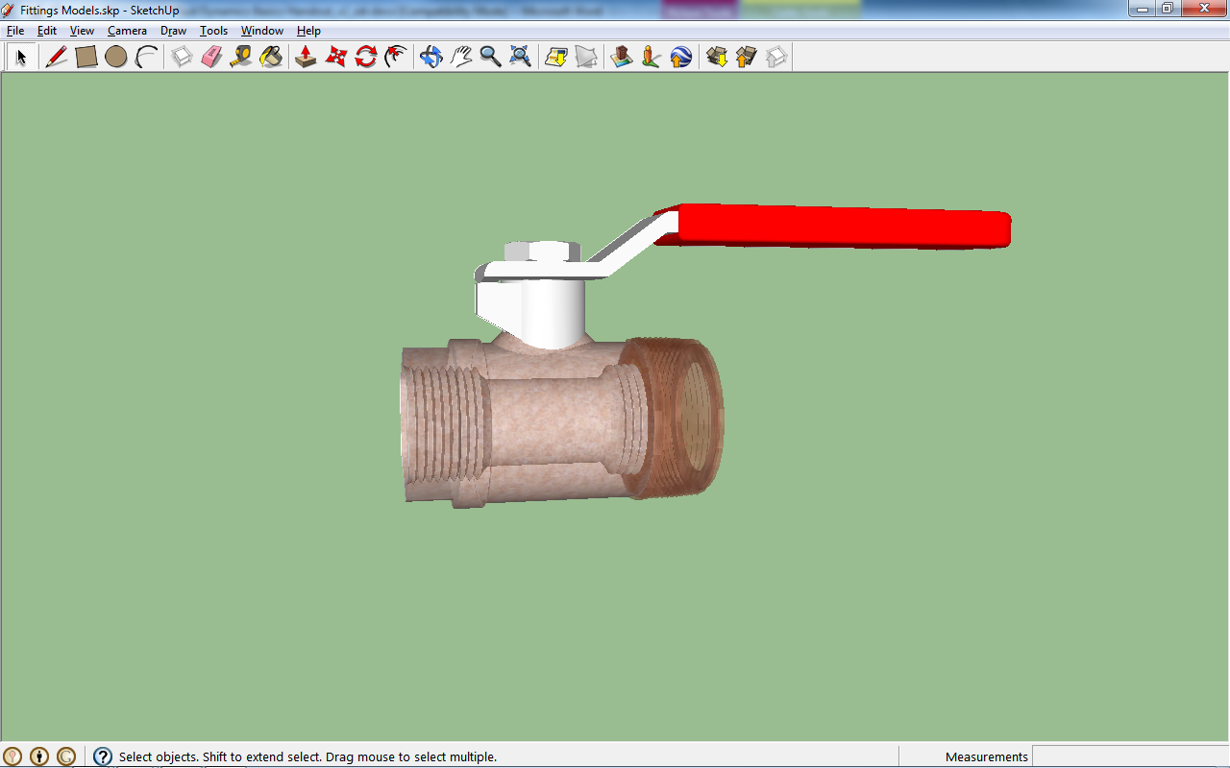 | 0.05
(Images source: Benjamin S. Terry, College of Engineering, University of Colorado at Boulder)
In our previous example, we considered a reservoir at the top of a hill and a piping system that carries the water to residences below. Consider a single leg of the pipeline that carries water from the reservoir to a residence, as illustrated in Figure 2.
Reservoir
Residence
Valve
Valve
Pipeline
Elbows
Figure 2. Pipeline from a reservoir to a single residence.
(Diagram source: Benjamin S. Terry, College of Engineering, University of Colorado at Boulder)
Questions:
- What fittings would you choose for this pipeline from the above table to minimize head loss?
- Assume that the water flowing through the pipe is traveling at 10 . What is the total head loss from the fittings you chose?
Fittings are not the only components in piping systems that cause losses. Friction between the water molecules and the surface of the pipe also contribute to head loss. Factors that influence head loss due to friction are:
- Length of the pipe ()
- Effective diameter of the pipe ()
- Velocity of the water in the pipe ()
- Acceleration of gravity ()
- Friction from the surface roughness of the pipe ()
The head loss due to the pipe is estimated by the following equation:
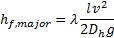
Question:
- Based on the above equation for , what factors will increase the head loss due to the flow of water through a pipe?
To estimate the total head loss in a piping system, one adds the head loss from the fittings and the pipe:
Note that the summation symbol ( ) means to add up the losses from all the different sources. A less compact-way to write this equation is:

Combining Bernoulli’s Equation With Head Loss
We can now combine the concepts of Bernoulli’s equation and head loss to understand the “Fluidic Energy Equation”. We divide each term in Bernoulli’s equation by the “specific weight” of the fluid (). The specific weight of a fluid is simply the density of the fluid multiplied by the acceleration of gravity: .Thus, the effects of head loss result in:
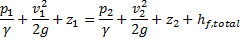
Recall our discussion of streamlines from the first section. The left side of this equation represents the state of a fluid particle at the start of our streamline, for example sitting in the water reservoir at the top of a hill. The right side of this equation is the state of our fluid particle at the end of our streamline, for example at the water tap of the residence at the bottom of a hill. The energy of the fluid particle in the reservoir is equal to the energy of the fluid particle at the tap plus the head losses. In other words, because of head losses, some of the energy is sapped from the fluid particle during its journey from the reservoir to the tap.
Again, consider our pipeline from the reservoir to the residential tap. Suppose you measure the pressure and velocity at two points in the piping system (along the same streamline) and discover that they are the same for both points. In other words, and .
Questions:
- If we now consider head losses along our streamline, what has to be true about the change in elevation between points one and two?
- If there are no change in elevation or pressure between points one and two, what would you expect the velocity to be at point two (), relative to point one?

