Tools and Equipment, Part I Activity –
Inclined Plane Worksheet

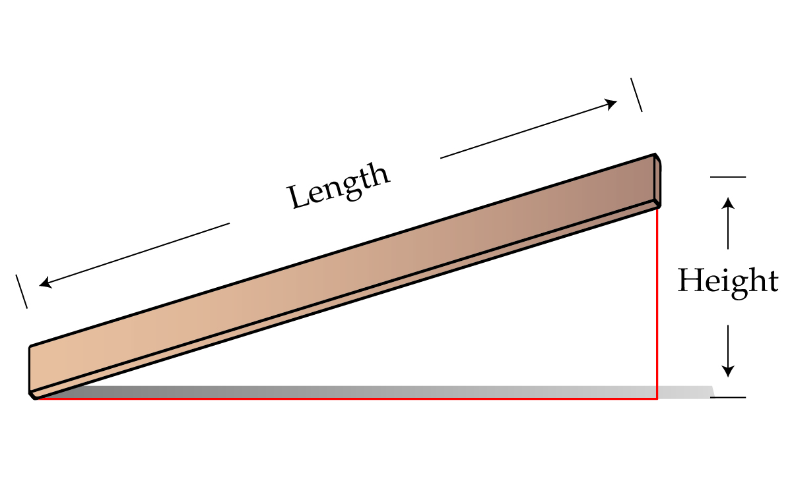
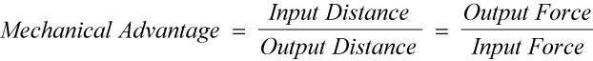
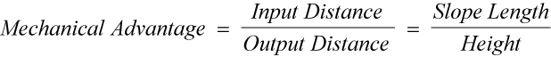
Instructions/Questions
- Measure the length and height of Inclined Plane A (1st station):
Length: ___________________ (cm)
Height: ___________________ (cm)
- What is the mechanical advantage based on these measurements? ____________
- What was the required force to raise the object?
Without the inclined plane: (Output force) _________ (g)
With the inclined plane: (Input force) _________ (g)
- What is the mechanical advantage based on these measurements? ____________
- Measure the length and height of Inclined Plane B (2nd station):
Length: ___________________ (cm)
Height: ___________________ (cm)
- What is the mechanical advantage based on these measurements? ____________
- What was the required force to raise the object?
Without the inclined plane: (Output force) _________ (g)
With the inclined plane: (Input force) _________ (g)
- What is the mechanical advantage based on these measurements? ____________
- Measure the length and height of Inclined Plane C (3rd station):
Length: ___________________ (cm)
Height: ___________________ (cm)
- What is the mechanical advantage based on these measurements? ____________
- What was the required force to raise the object?
Without the inclined plane: (Output force) _________ (g)
With the inclined plane: (Input force) _________ (g)
- What is the mechanical advantage based on these measurements? ____________
- Measure the length and height of Inclined Plane D (4th station):
Length: ___________________ (cm)
Height: ___________________ (cm)
- What is the mechanical advantage based on these measurements? ____________
- What was the required force to raise the object?
Without the inclined plane: (Output force) _________ (g)
With the inclined plane: (Input force) _________ (g)
- What is the mechanical advantage based on these measurements? ____________
Results
- Did you obtain different mechanical advantages for the different methods of measuring? If so, was the difference large?

- Which inclined plane had the greatest mechanical advantage?

Conclusions
- Does calculating mechanical advantage just with the dimensions of the inclined plane really work? That is, does the calculation describe what really happens? Write a short paragraph explaining your answer.

- If you are the engineer designing a ramp for a construction site to move a wheelbarrow a height of 100 feet, which inclined plane would you use? Why?

- What are some possible sources of error in this experiment?

