**Tools and Equipment, Part II Activity – Pulley Worksheet**

**Instructions/Questions**

1. What is the measured weight of your object? Load = ___________
2. 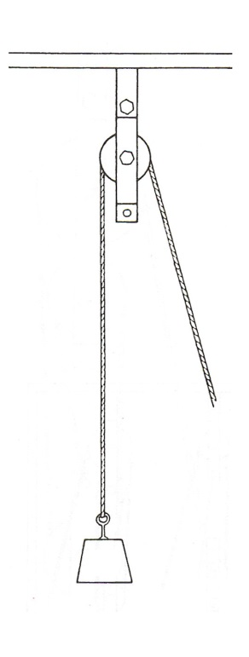How is the Mechanical Advantage of a pulley system calculated?
3. **Set up your pulley, weight and rope as shown at right.**
4. What is the theoretical Mechanical Advantage of this system?

MA = ___________

1. What is the required force to raise object higher?

Effort = ___________

1. Calculate the actual Mechanical Advantage of the pulley system using the following equation:



1. How does this compare to the theoretical MA from above?

1. 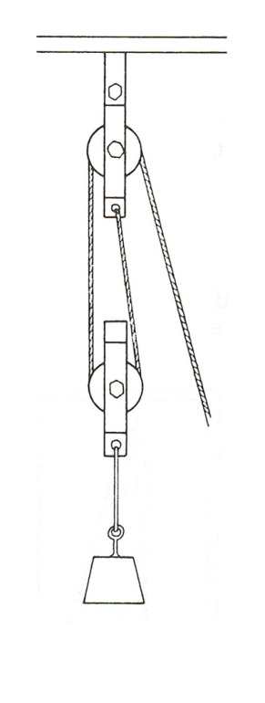**Support your load according to the pulley setup shown at right.**
2. What is the theoretical Mechanical Advantage of this system?

MA = ___________

1. What is the required force to raise object higher?

Effort = ___________

1. Calculate the actual Mechanical Advantage of the pulley system using the following equation:



1. How does this compare to the theoretical MA from above?

1. 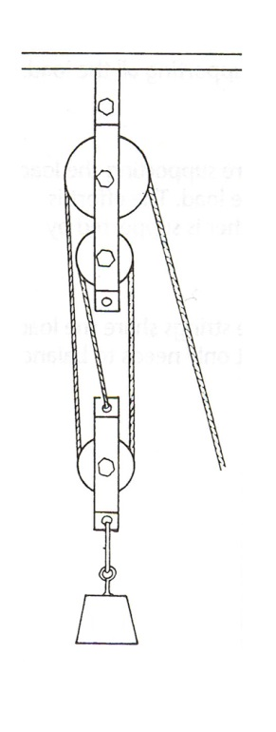**Add another pulley to your system as shown to the right.**
2. What is the theoretical Mechanical Advantage of this system?

MA = ___________

1. What is the required force to raise object higher?

Effort = ___________

1. Calculate the actual Mechanical Advantage of the pulley system using the following equation:



1. How does this compare to the theoretical MA from above?

**Results**

In general, were the theoretical mechanical advantages similar to the actual ones?

**Discussion**

1. What were some sources of error in your experimental procedure?

1. What recommendations would you make as engineers trying to move the gray whale back to the ocean? Would you use pulleys? Why or why not?

1. What are some constraints that you as engineers might consider while designing a pulley system for the whale?

1. What impacts to the whale might you need to consider for moving it back to the ocean?

1. Calculate the percent error in the mechanical advantage of the actual pulleys compared to the theoretical pulleys.

$$\% Error= \left|\frac{Theoretical Value-Actual Value}{Actual Value}\right|*100$$

**Pulley Setup A:**

**Pulley Setup B:**

**Pulley Setup C:**