Rube Goldberg Worksheet Answers

Instructions
When Rube Goldberg showed his “self-operating napkin” machine to his friend, he said it would not work. Prove to Rube Goldberg’s friend that the invention will really work by using the information given and what you know about mechanical advantage and work. Remember the following equations:

Work (in Joules, J) = Force (Newtons, N) x Distance (m)

Mechanical advantage of a lever = Distance of effort (applied force) to fulcrum
Distance of load (weight) to fulcrum

Mechanical advantage = Force_out (that is, the resulting force)
Force_in (that is, the force applied initially)

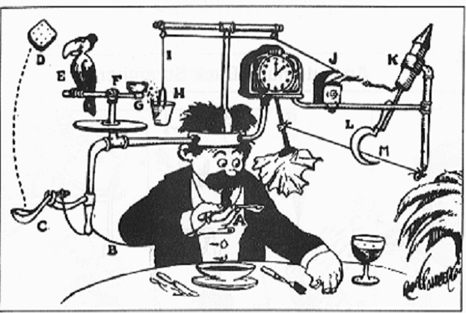
Figure 1. Rube Goldberg’s “self-operating napkin”
Analysis Questions
Answer the following questions, referring to Figure 1, above.

- You raise your spoon filled with soup 0.15 meters high with 2 Newtons of force.
How much work did you do?
0.3 Newton-meters, or 0.3 Joules (J) (W = 2 N x 0.15 m = 0.3 J)

- The spoon is attached to a string that gets pulled as you move the spoon.
How much work is transferred?
0.3 J

- The string jerks the ladle, which is a lever. A cracker is sitting inside the ladle. The string (that gets pulled) is attached 10 cm from the fulcrum and the cracker is 0.5 m from the fulcrum. What is the mechanical advantage?
1/5 = 0.2
MA = Distance of effort (string pulled) to fulcrum= 10 cm * (1 m/100 cm) = 0.1 m
Distance of load (cracker) to fulcrum = 0.5 m
= 0.1 m/0.5 m = 1/5 = 0.2

- The ladle throws a cracker past a parrot. (E) The parrot jumps after the cracker, applying force to the perch he sits on. (F) The perch spins around, throwing the seeds into a pail. The perch is another lever. It has a mechanical advantage of 2. If it takes 0.5 J of work to move the seeds 0.1 m without the lever, how much force is needed with the lever?
2.5 N
(F needed w/ lever Distance of load = MA x Distance of effort = 2 x 0.1 m = 0.2 m
F needed w/lever = Work/distance = 0.5 J / 0.2 m = 2.5 N)
(Note: F needed without lever = W/d = 0.5 J/ 0.1 m = 5 N, thus by using a lever, the force required to move the object [seeds] is reduced.)
- The extra weight from the seeds in the pail pulls a cord, which goes around a pulley and opens and lights an automatic cigar lighter. If the pail can apply 3 N of force to the cord, and the pulley system has a mechanical advantage of 2, how much total force can be applied to the match?
6 N (MA = F_out/ F_in F_out = MA * F_in = 2 * 3 N = 6 N)

- The match sets off the rocket, which causes a sickle to cut the string, releasing a pendulum with an attached napkin to swing back and forth, wiping off your chin. If 3 N of force is needed to strike the match, will the system work? Why or why not?
Yes, because 3 N is less than 6 N.

