Surveyor’s Report Worksheet
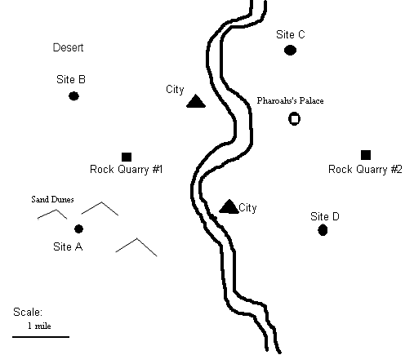

Pyramid Sites
Site A: Hard rocky surface. Uneven and steep. Near sand dunes.
Site B: Desert location near an oasis. Thin layer of sand, with solid rock below.
Site C: High flat ground with exposed bedrock for the foundation.
Site D: Soft, sandy soil. Bedrock deep below the surface.

- Discuss with your team the important factors to consider in picking a good site for your pyramid. List your ideas below (and on the back of this sheet if you need more room➔).

- Rank the order of importance of all your factors listed above by writing 1, 2, 3, etc. next to each factor on your list. (#1 is the most important, #2 is the next most important, etc.)
- Which site have you chosen to build the pyramid? ______ Circle the site on the map.
- Why did you choose this site? Write at least three sentences describing the advantages of this site compared to the others (use the back of this sheet if you need more room).

